

**CIA 3**

**NAME : KHUSHI SANWAL**

**CLASS : 3BScDS**

**REGISTER NO : 2341447**

**SUBMITTED TO : UMMESALMA M MA’AM**

**SUBJECT : DATA VISUALIZATION (DSC201-3)**

**PROBLEM STATEMENT**

To reduce inequality within and among countries, this analysis will explore the relationship between **Financial Soundness Indicators** (such as GDP per capita, labour wages and unemployment rates) and the **Proportion of developing country’s voting rights** in international organizations mainly focusing on India and other SAARC(South Asian Association for Regional Cooperation) countries.

**INTRODUCTION**

Inequality is still a major problem that affects unity in society and economic stability, especially in developing nations. Financial Soundness Indicators show the major differences that impede fair growth and social mobility, such as GDP per capita, labour wages and unemployment rates.  
  
Furthermore, developing country’s involvement in international organizations is essential for influencing the creation of policies that specifically address their economic difficulties. Many developing nations, despite having sizable populations are underrepresented and have restricted voting rights in important institutions which limits their capacity to push for reforms that are vital. The purpose of this analysis is to investigate the relationship that exists between Financial Soundness Indicators and emerging nation’s ability to vote in international organizations.

By looking at these interrelated elements, we may find ways to promote equitable governance and lessen inequality, which will ultimately lead to sustainable economic growth and a more equitable world.

**NEED FOR ADDRESSING THE PROBLEM STATEMENT**

1. **Widening Inequality**: The gap in wealth and opportunities between countries is increasing, affecting global stability and social cohesion.
2. **Economic Growth**: Reducing inequality is vital for sustainable economic growth; equitable distribution of resources fosters a more robust economy.
3. **Financial Soundness Indicators:** Indicators like GDP per capita, labour wages and unemployment rates reveal economic health and disparities that need urgent attention.
4. **Underrepresentation:** Developing countries often lack adequate representation in international organizations, limiting their influence on policies that impact their economies.
5. **Policy Impact**: Strengthening the voting rights of developing nations allows them to advocate for policies that address their unique challenges and needs.
6. **Global Cooperation**: Addressing inequality encourages cooperation among nations, fostering collaborative solutions to shared global issues.
7. **Social Stability:** Reducing disparities contributing to social stability, reducing unrest and promoting peace within and among countries.
8. **Moral Imperative:** Ensuring equal representation and opportunities is a fundamental human right, crucial for justice and equity in the global community.

**OBJECTIVES**

1. **Analyse Average GDP per Capita:** Compare the average GDP per capita across countries, with a focus on India and SAARC nations, to understand economic disparities.
2. **Examine Average Wages by Gender:** Analyse gender wage gaps in India and SAARC countries to highlight economic inequalities based on gender.
3. **Study Wages by Education:** Evaluate how education affects average wages in India and SAARC countries, identifying the impact of educational attainment on economic equality.
4. **Track Wage Trends Over Time:** Analyse trends in average wages in SAARC (2015-2023) and India (2018-2023) to assess wage growth and its implications for reducing inequality.
5. **Assess Unemployment Rates and Rankings:** Compare average unemployment rates and rankings of India and SAARC countries to understand labour market inequalities.
6. **Evaluate Financial Stability Rates**: Assess the average rate of financial stability in India and SAARC countries, examining how financial stability impacts inequality.
7. **Compare HDI Values:** Compare Human Development Index (HDI) values across northern countries, including Russia and other countries to measure overall well-being and inequality.
8. **Examine Voting Rights in International Organizations:** Study the average proportion rates for members and voting rights of India and SAARC countries in international organizations to understand their influence in global decision-making.
9. **Analyse Voting Rights Over Time:** Compare changes in the proportion rates for members and voting rights in India and SAARC over time to assess their evolving role in international organizations.
10. **Recommend Policy Changes**: Provide strategic policy recommendations based on the analysis to promote financial soundness, fair wages and equitable voting rights in global governance.

**ANALYSIS AND INTERPRETATION**

**10.5. - 1. AVERAGE GDP PER CAPITA**

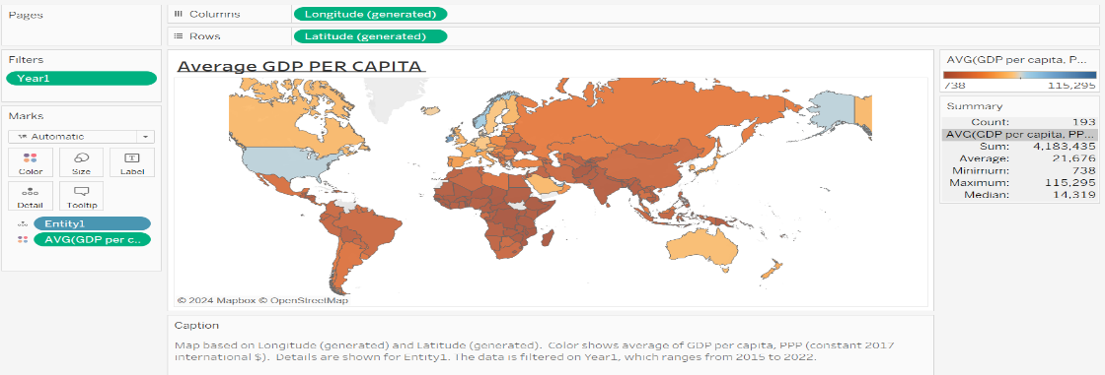

**ANALYSIS –** This world map visualizes the GDP per capita across countries. Darker shades of blue represent higher GDP per capita, while Darker shades of red indicate lower values. North America, Western Europe and parts of East Asia (like Japan and South Korea) exhibit the highest GDP per capita. In contrast, many African and South Asian countries, including India and parts of sub-Saharan Africa, show significantly lower GDP per capita.

**INTERPRETATION –** The map reveals global economic inequality. Developed regions such as the US, Canada, Western Europe and Japan lead in wealth per capita, highlighting their advanced economies and industrialization. Conversely, developing countries in Africa and South Asia have lower GDP per capita, reflecting challenges like poverty, lower industrialization and infrastructure deficits. Economic policies or global trends, such as trade and investment, contribute to these disparities.

**10.5. - 2. INDIA’S AVERAGE GDP PER CAPITA**

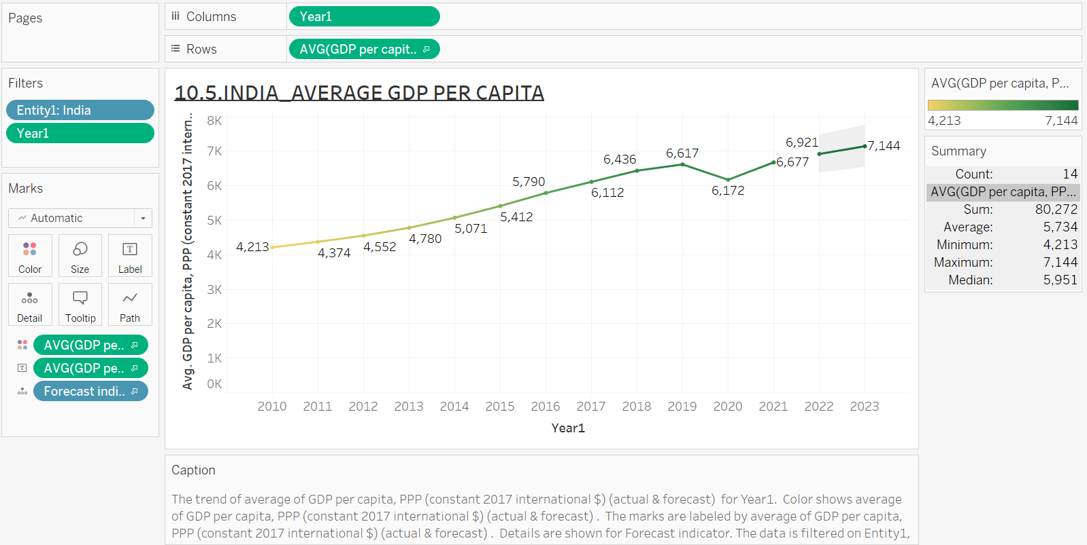

**ANALYSIS –** The line chart tracks India's GDP per capita from 2010 to 2023. There is a steady rise in GDP per capita, with a visible increase after 2017. In 2015, GDP per capita was around $5,412, reaching approximately $6,677 in 2021. Despite minor fluctuations in 2020, the trend shows an overall growth trajectory. We also use forecast to predict the coming years average GDP per capita and found a predicted value of $6,921 in year 2022 and $7144 in year 2023.

**INTERPRETATION –** The consistent rise in India's GDP per capita suggests sustained economic growth, driven by industrialization, technological advancements and policy reforms. The dip in 2020 likely reflects the economic impact of the COVID-19 pandemic, but the recovery afterward signals resilience. This growing per capita income reflects improving living standards and economic potential in India.

**10.5. - 3. SAARC’S AVERAGE GDP PER CAPITA**

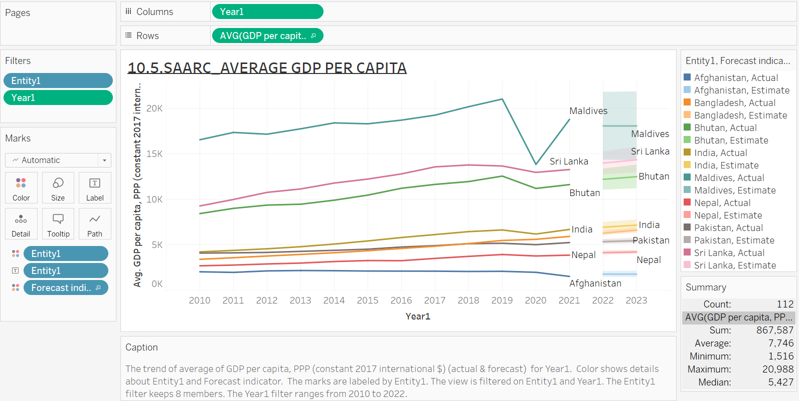

**ANALYSIS –** This line chart compares the GDP per capita of SAARC countries from 2010 to 2023. The Maldives has a significantly higher GDP per capita compared to other countries, showing a steep rise after 2017. Sri Lanka and Bhutan exhibit moderate growth, while India has steady but slower growth. Afghanistan, however, shows the lowest and relatively stagnant GDP per capita in the region.

**INTERPRETATION –** The Maldives' high GDP per capita highlights its economic focus on tourism and services, which drive its growth. India's steady increase shows progress in its diversified economy, while Sri Lanka and Bhutan also show moderate development. Afghanistan's low and stagnant GDP reflects ongoing political instability, conflict and weak infrastructure, hindering economic development. This chart underscores the economic diversity within the SAARC region.

**10.5. - 4. INDIA’S AVERAGE WAGES BY GENDER**

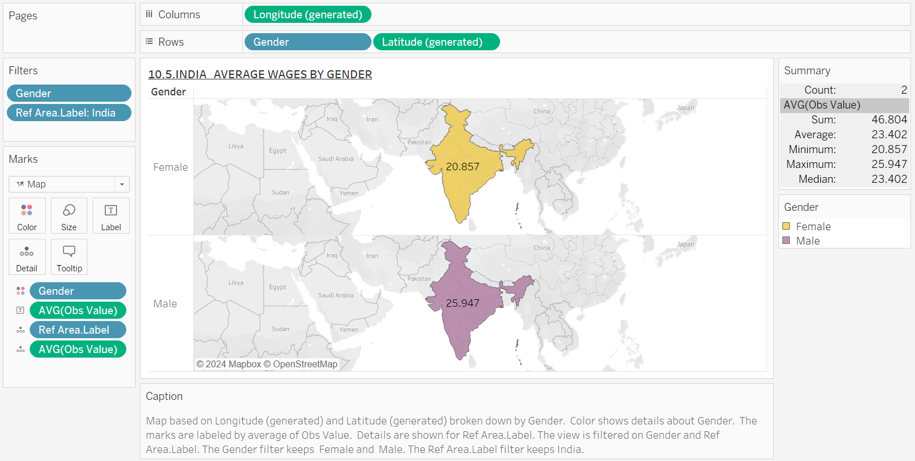

**ANALYSIS –** This map presents the average wages of males and females in India. The average male wage is slightly higher (around $25.947) compared to females (around $20.857). The map uses shading to highlight the wage difference by gender across regions in India.

**INTERPRETATION –** Gender wage disparity remains a persistent issue in India, with males earning marginally more than females. The small wage gap suggests improvements in some areas, but societal norms, gender roles and occupational segregation still contribute to this inequality. These regional wage patterns reflect underlying socio-economic factors that continue to influence wage gaps across genders. Addressing gender-based barriers in education, employment and pay equity is critical for reducing this disparity.

**10.5. - 5. SAARC’S AVERAGE WAGES BY GENDER**

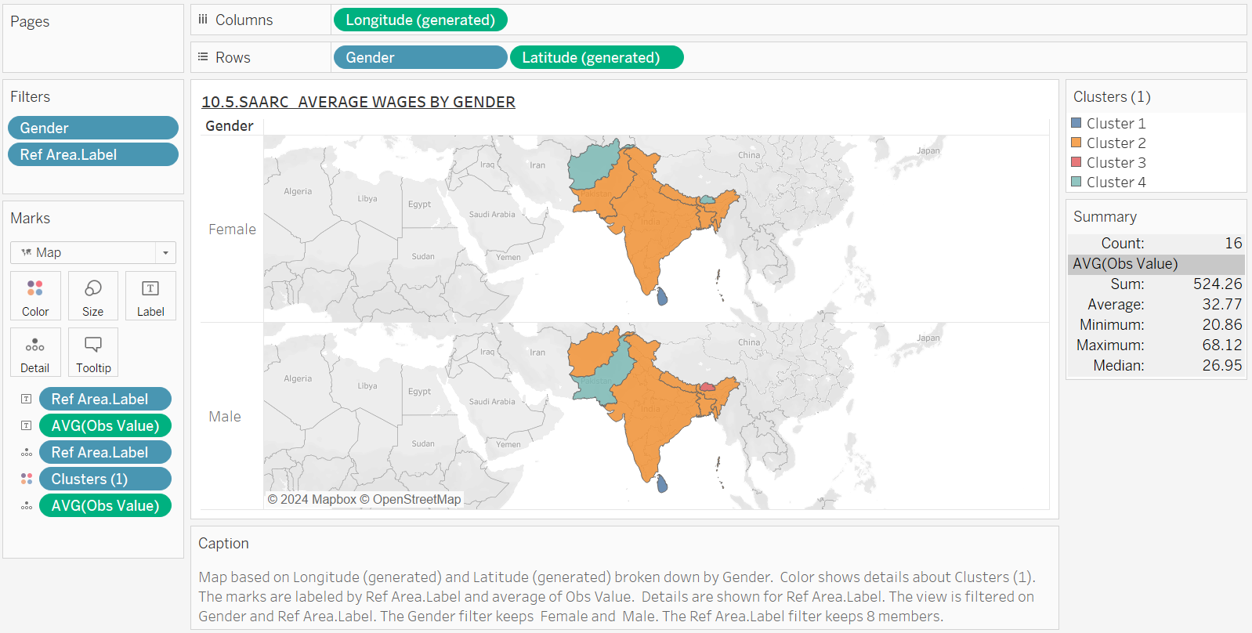

**ANALYSIS –** This map visualizes the average wages of males and females in SAARC countries, with India highlighted. Different shades of orange indicate wage disparities. For example, males earn more than females in most regions.

**INTERPRETATION –** This map visualizes gender wage disparities across SAARC countries, similar to India. The wage gap remains prevalent throughout the region, with males earning consistently more than females. This points to a regional issue of gender inequality in employment sectors across SAARC.

**10.5. - 6. SAARC’S AVERAGE WAGES BY EDUCATION**

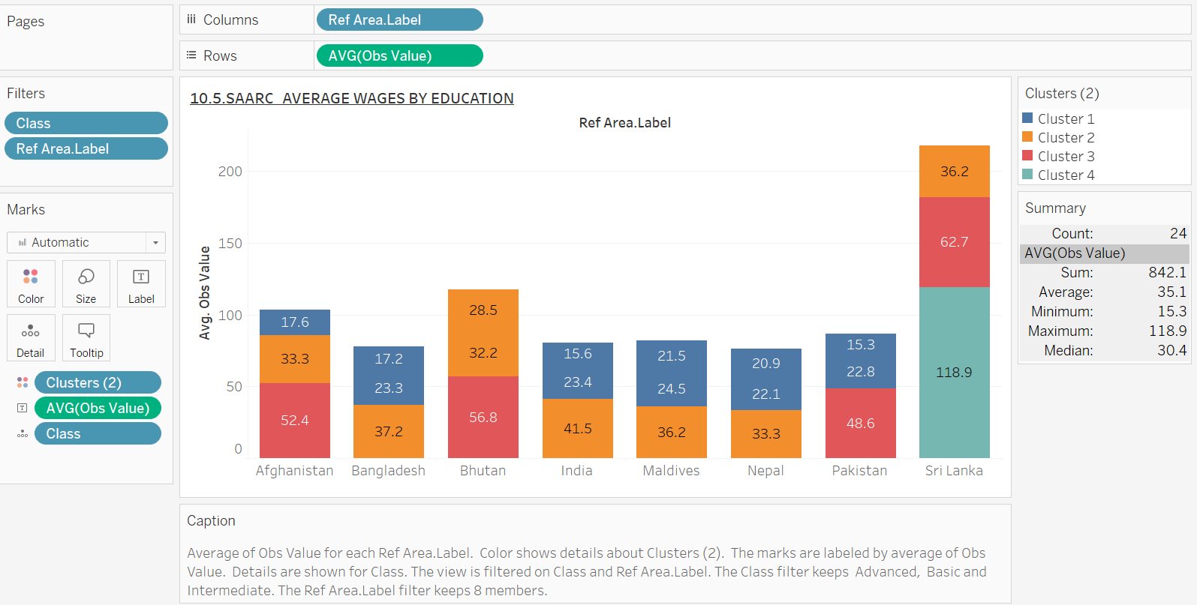

**ANALYSIS –** This stacked bar chart shows the average wages for different education levels across the SAARC countries. Education levels include categories like basic, intermediate and advanced degrees, with each bar segment representing a specific education tier and the corresponding wages.

**INTERPRETATION –** The chart clearly indicates that as education level increases, so do wages across the SAARC region. Individuals with advanced degrees earn significantly more than those with only basic or intermediate education. This highlights the critical role of higher education in driving economic mobility, suggesting a need for policies that improve educational access and quality, particularly in less developed countries.

**10.5. - 7.INDIA’S AVERAGE WAGES BY EDUCATION**

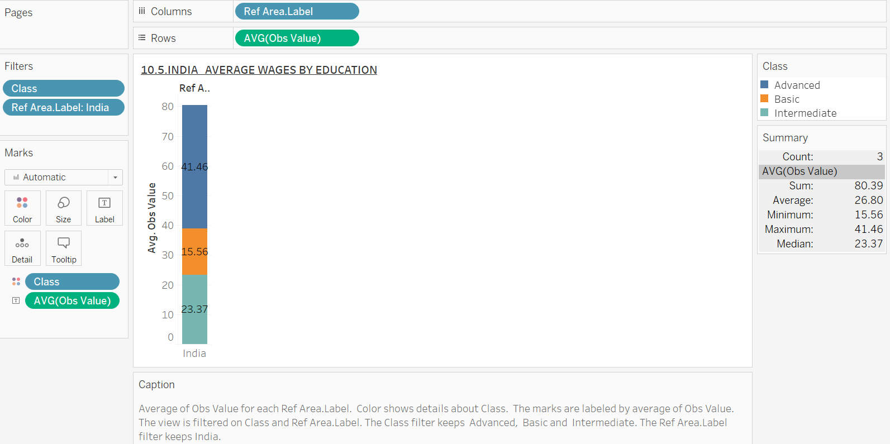

**ANALYSIS –** This bar chart illustrates the average wages in India categorized by education level, including basic, intermediate and advanced degrees. The increasing height of the bars reflects higher wages for individuals with greater educational qualifications, emphasizing the importance of education in determining earning potential.

**INTERPRETATION –** The graph highlights a clear positive correlation between education and wages in India. Individuals with tertiary and advanced degrees earn significantly more than those with only primary or secondary education. This underscores the critical need for investment in education, particularly in higher education, as it can enhance earning potential and contribute to reducing poverty levels in India. Expanding access to quality education can lead to a more skilled workforce and drive economic growth in the country.

**10.5. – 8. SAARC’S AVERAGE WAGES FROM YEAR 2015-23**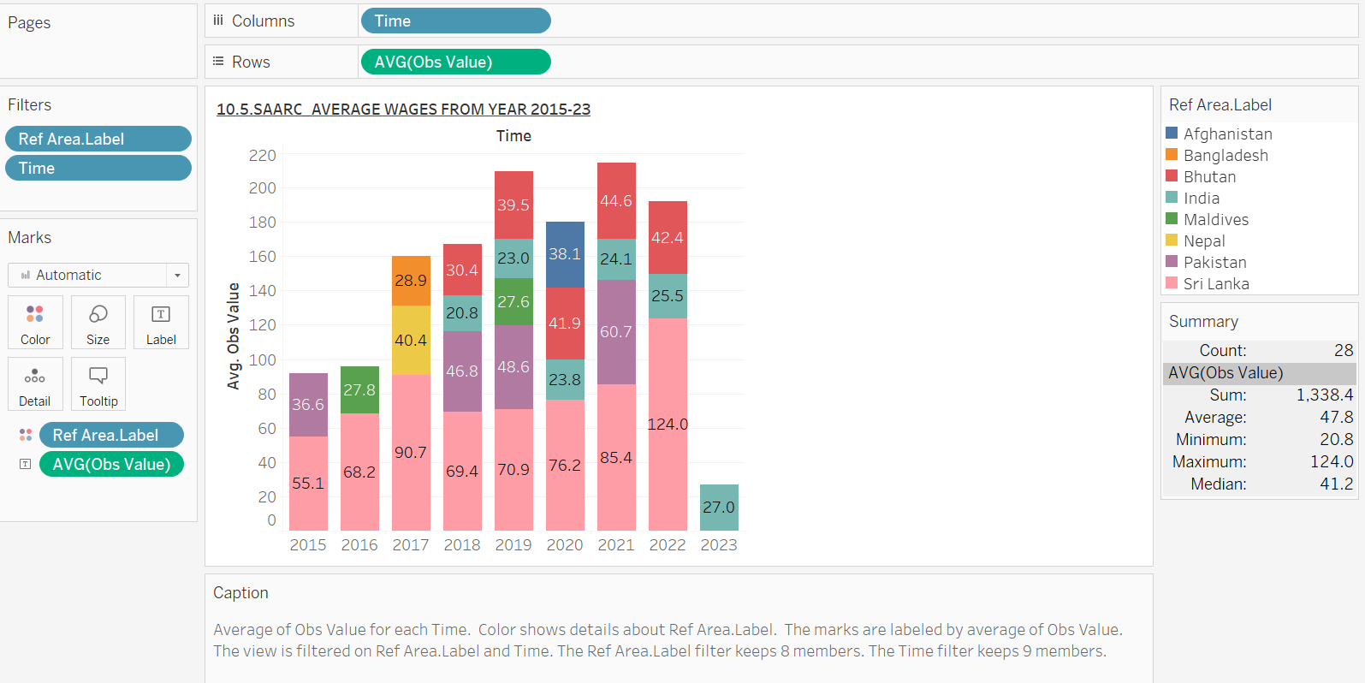

**ANALYSIS –** This graph tracks the average wages of individuals based on education level within the SAARC region from 2015 to 2023. The stacked bars represent different education levels, showing consistent growth over time, particularly in advanced education categories.

**INTERPRETATION –** The steady increase in wages over the years, especially for those with higher education, shows the growing importance of education in the SAARC region. This upward trend suggests a rising demand for highly skilled workers. Policymakers in these countries should prioritize access to quality education to meet labour market demands and promote inclusive economic growth.

**10.5. – 9. INDIA’S AVERAGE WAGES FROM YEAR 2015-23**

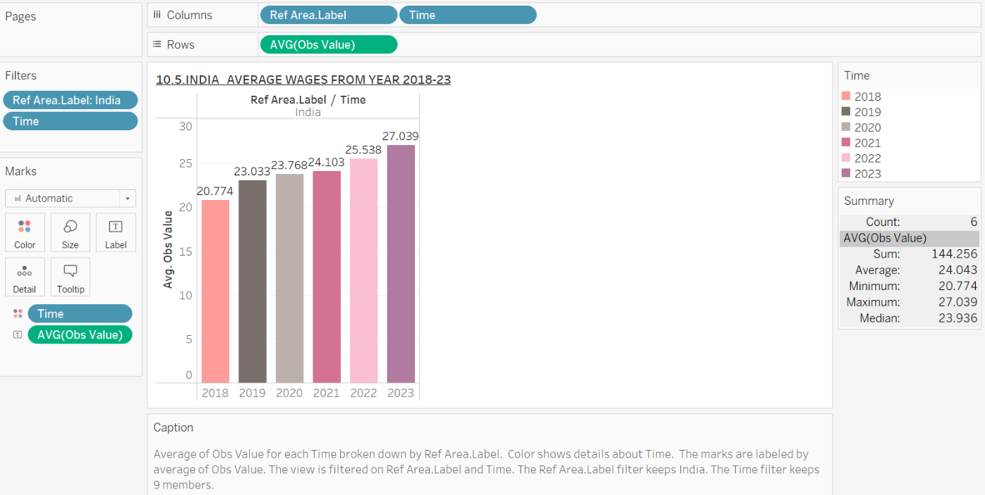

**ANALYSIS –** This bar chart presents the average wages of males and females in India over time, showing data from 2018 to 2023. It shows a steady increase over the years.

**INTERPRETATION –** The chart reflects the overall wage trends in India, indicating changes in average wages over the specified years. This indicates a positive movement in wage levels, reflecting improvements in economic conditions and earning potential within the country. The data highlights the growth in average wages, suggesting a favourable labour market environment.

**10.5. – 10. AVERAGE UNEMPLOYMENT RATE**

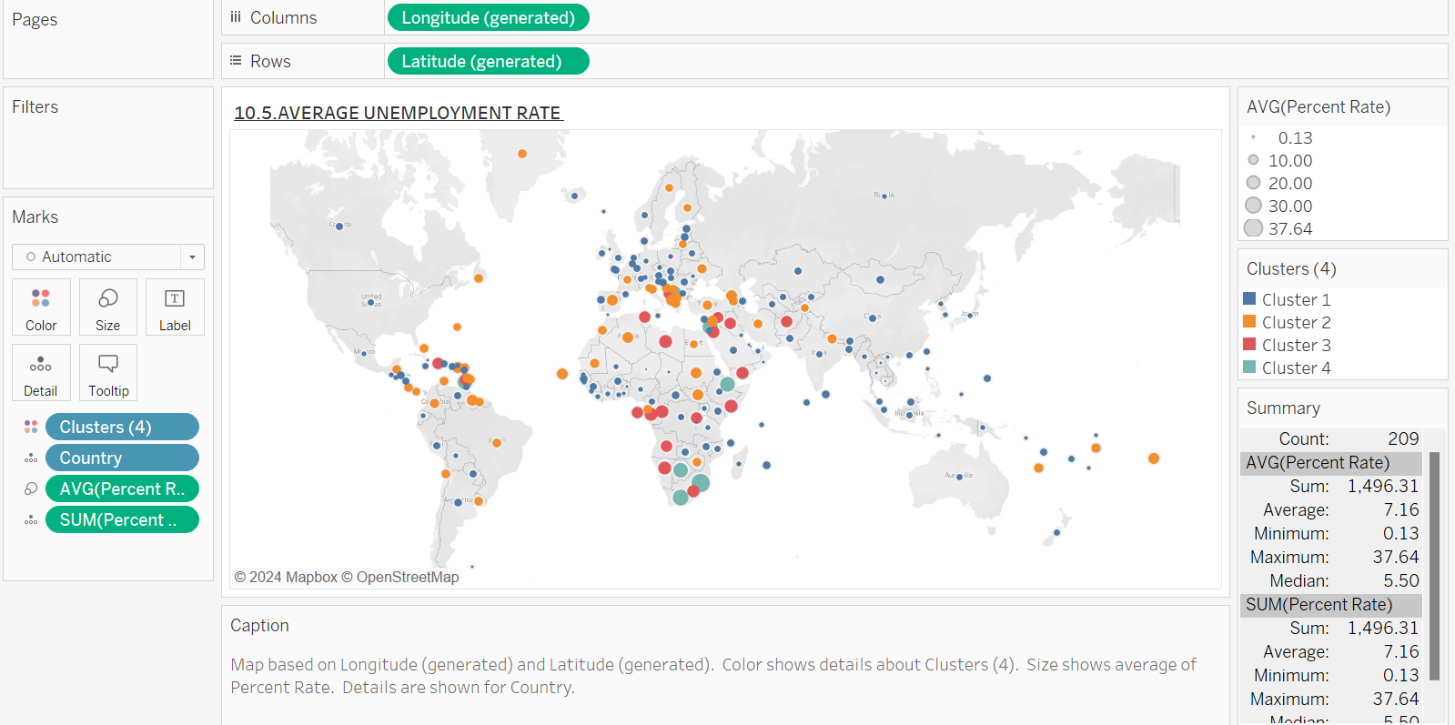 **ANALYSIS –** This map displays global unemployment rates, with countries represented by coloured dots. Higher unemployment rates are concentrated in certain regions, particularly in Africa, the Middle East and parts of Europe.

**INTERPRETATION –** This map highlights significant global disparities in unemployment. Developing nations, particularly in Africa and the Middle East, tend to have higher unemployment rates due to factors like political instability, lack of infrastructure and economic challenges. In contrast, developed regions show lower unemployment, reflecting more stable economies. Addressing unemployment requires tailored economic policies, particularly in regions with systemic issues like conflict and inadequate job creation.

**10.5. – 11. SAARC’S AVERAGE UNEMPLOYMENT RATE**

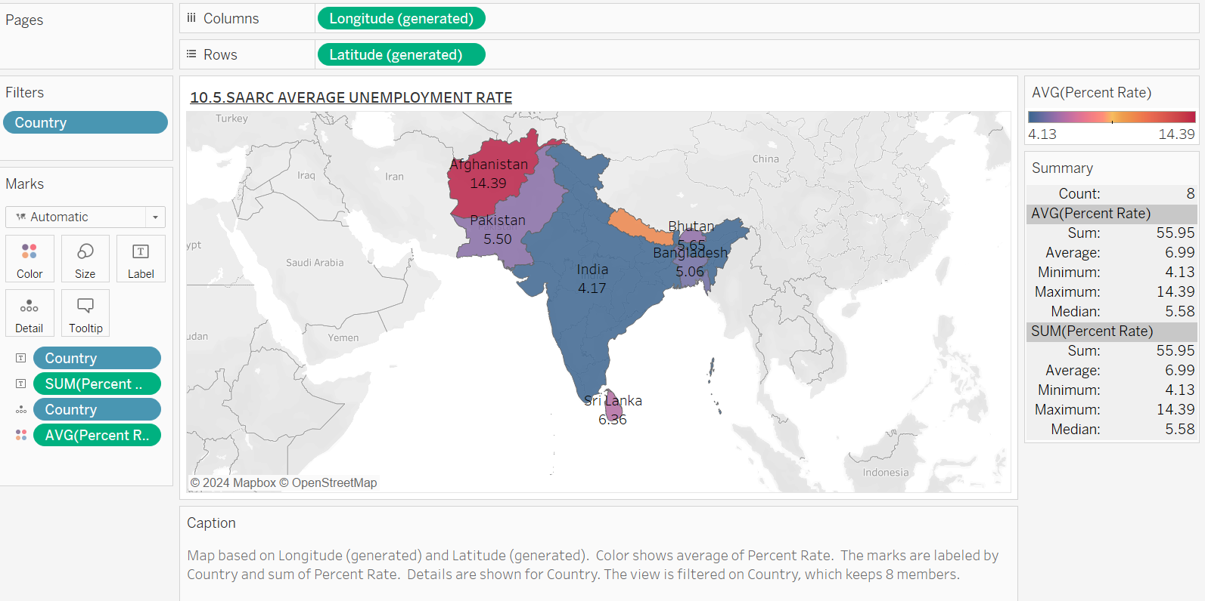

**ANALYSIS –** This map visualizes the average unemployment rates across SAARC countries, with colour coding to indicate varying levels of unemployment. Countries like India and Pakistan exhibit lower unemployment rates, while Afghanistan shows higher rates.

**INTERPRETATION –** The graph illustrates the disparity in unemployment rates among SAARC nations, emphasizing that certain countries face more significant employment challenges. The higher unemployment rates in Afghanistan may require focused economic policies to address job creation, while the lower rates in India and Bangladesh suggest more stable job markets.

**10.5. – 12.INDIA’S AVERAGE UNEMPLOYMENT RATE**

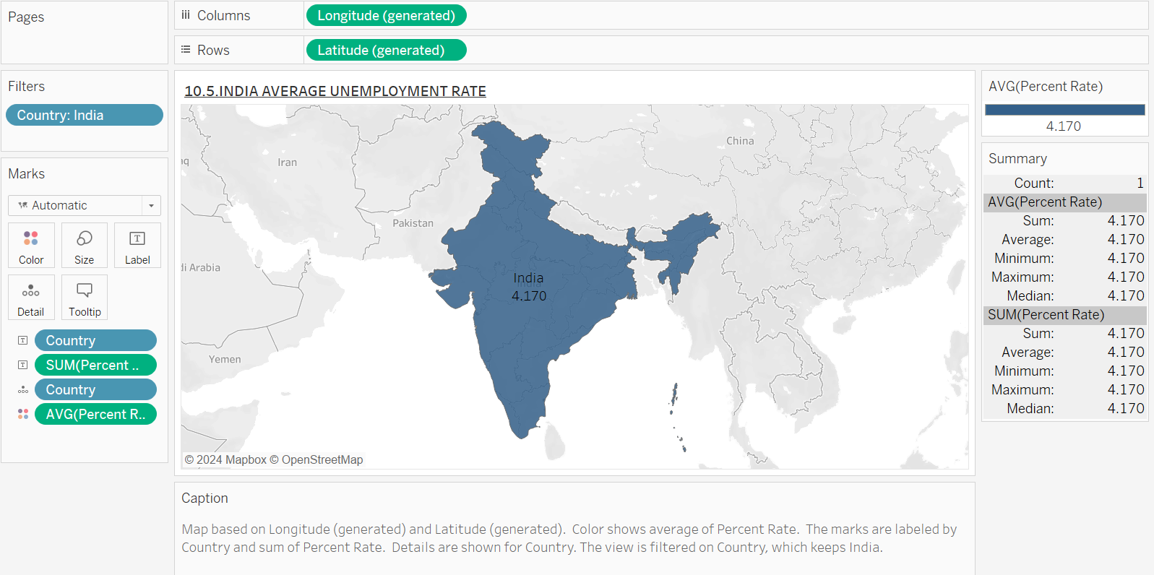

**ANALYSIS –** This map presents the average unemployment rate specifically for India. Generally, states such as Uttar Pradesh and Bihar display higher unemployment levels compared to southern states like Kerala and Tamil Nadu, which show lower rates.

**INTERPRETATION –** The regional differences highlight the economic challenges faced by northern states, suggesting that targeted interventions are needed to stimulate job growth in these areas. In contrast, the more favourable unemployment rates in southern states indicate better employment conditions, which could serve as models for policy implementation.

**10.5. – 13. SAARC’S AVERAGE UNEMPLOYMENT RANKING**

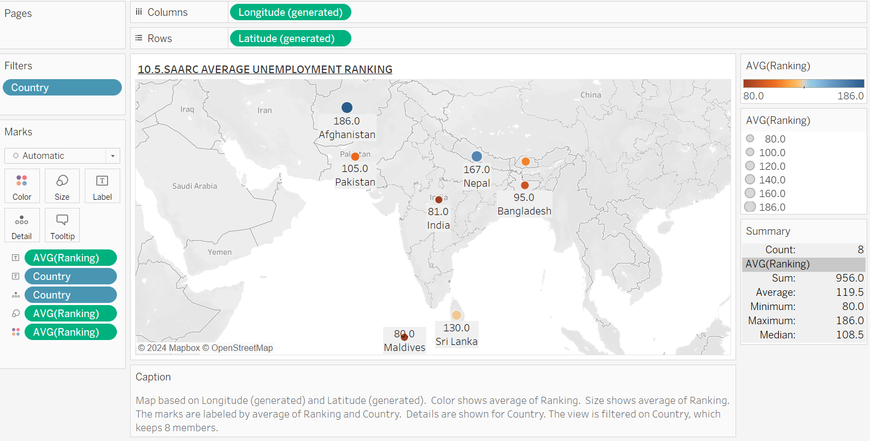

**ANALYSIS –** This graph provides a ranking of SAARC countries based on their average unemployment rates. Each country's ranking is visually depicted on a map, indicating how they compare to one another in terms of unemployment performance. Lower rankings indicate better employment situations.

**INTERPRETATION –** The ranking provides insight into the relative employment health of each country, emphasizing that nations like India and Maldives rank higher in unemployment. This comparative analysis can guide regional cooperation and strategic planning to tackle unemployment collectively.

**10.5. – 14.INDIA’S AVERAGE UNEMPLOYMENT RANKING**

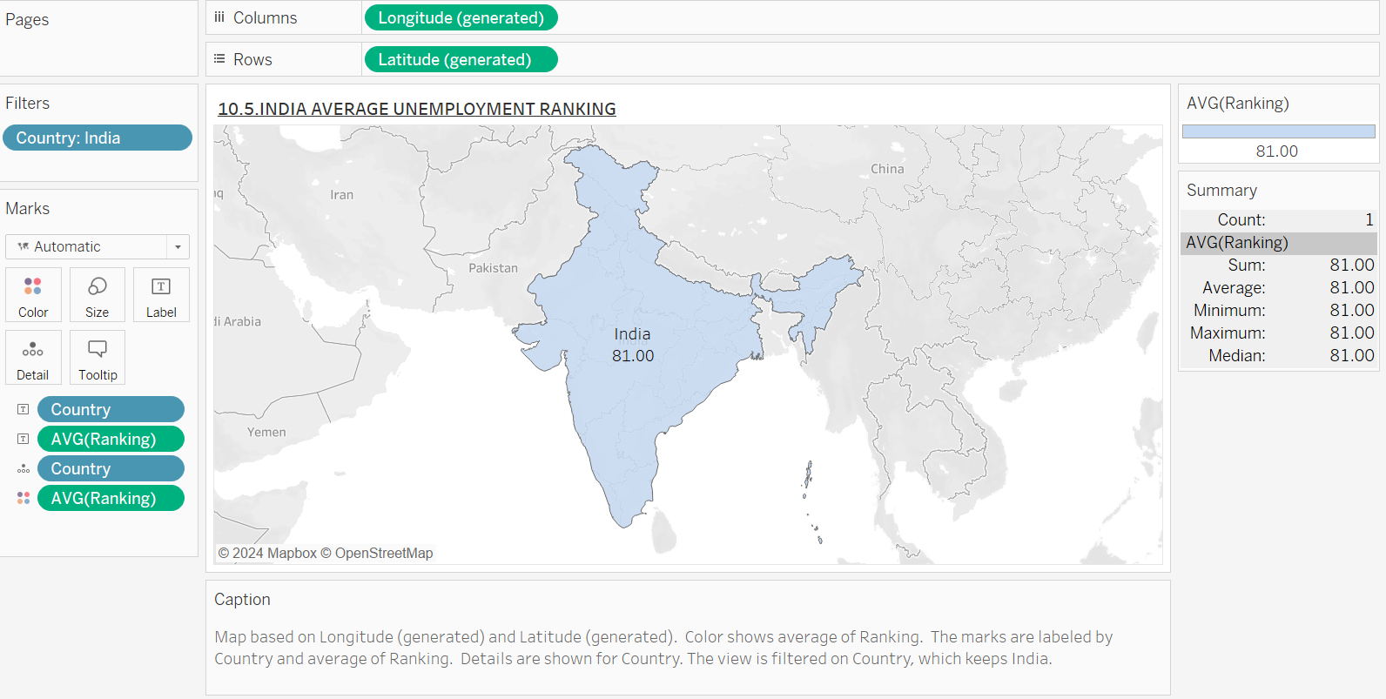

**ANALYSIS –** This map highlights India's position in the context of unemployment rankings among its states. Generally, states such as Bihar and Uttar Pradesh are ranked higher in unemployment, indicating a pressing need for economic intervention.

**INTERPRETATION –** Understanding the unemployment ranking within India underscores the necessity for state-level policies aimed at reducing joblessness. The disparities in ranking can inform where resources should be directed to foster economic development and employment opportunities.

**10.5. – 15. AVERAGE RANKING FOR COUNTRIES**

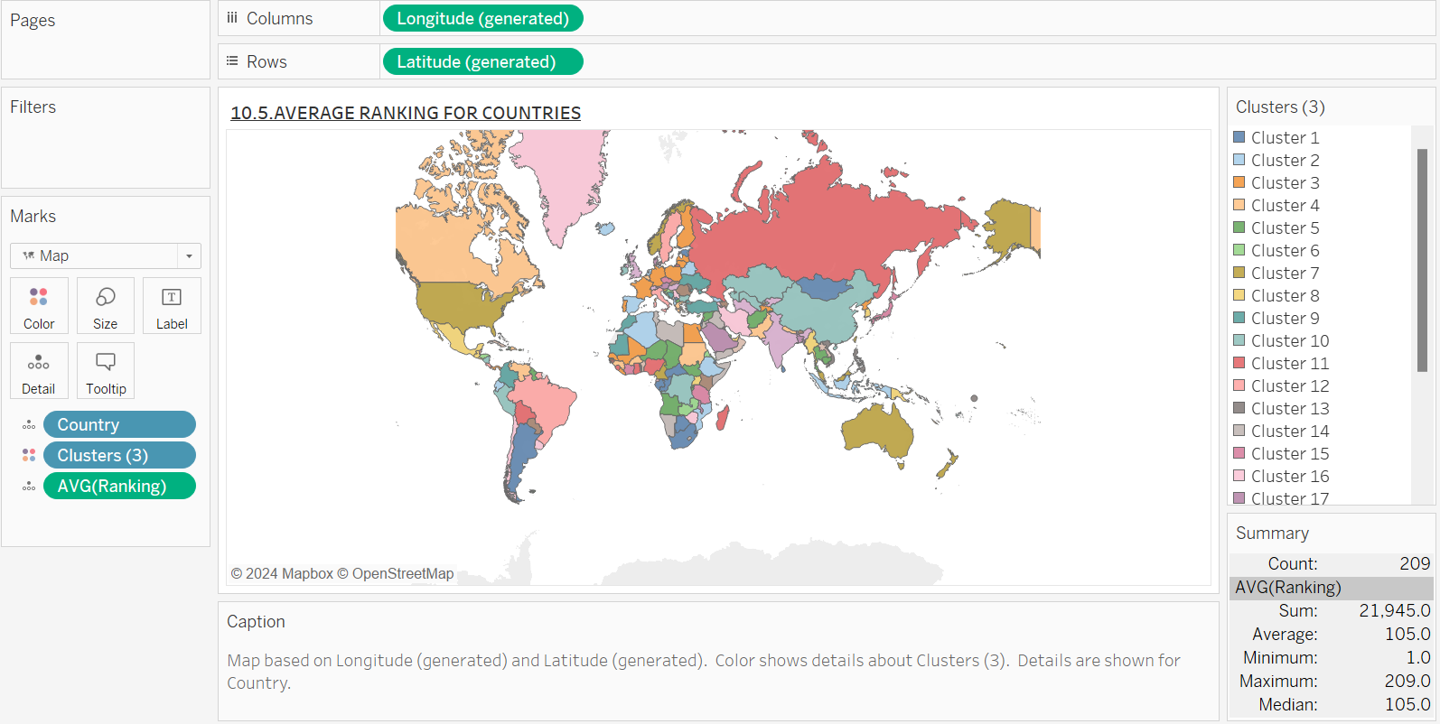

**ANALYSIS** – This map displays average rankings of various countries concerning unemployment, providing a broad perspective on global unemployment rates. Countries are color-coded to represent their relative standing in terms of employment.

**INTERPRETATION** – This comparative view allows for an understanding of how countries, especially India, fare against global standards in unemployment. It highlights the need for tailored policies in higher-ranked countries to improve employment outcomes.

**10.5. – 16. SAARC’S AVERAGE RATE OF FINANCIAL STABILITY(LEAVING AFGHANISTAN – DATA NOT PROVIDED)**

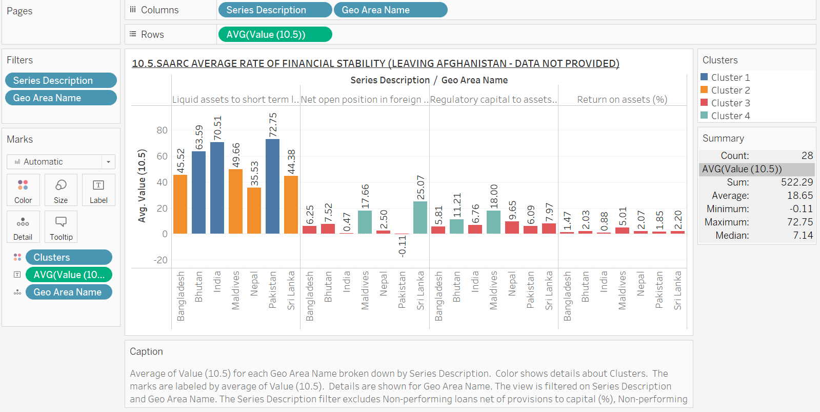

**ANALYSIS –** This bar chart presents the financial stability rates for SAARC countries, excluding Afghanistan. The financial stability rate is represented for countries like India, Pakistan, Bangladesh, Sri Lanka and others. The bars are color-coded by country and are clustered too. Some countries demonstrate consistent performance while others show more volatility in financial stability rankings.

**INTERPRETATION –** The graph highlights the varying levels of financial stability among SAARC nations. India shows relatively steady financial stability while countries like Sri Lanka and Pakistan experience fluctuations, indicating economic challenges. This variation in financial stability can impact economic growth, influencing factors like employment rates and foreign investment. Countries with better financial stability rankings tend to have more robust economic environments, which could lead to more sustainable growth. The data suggests that improving financial stability could be a priority for countries with volatile rankings to foster long-term economic stability in the region.

**10.5. – 17. INDIA’S AVERAGE RATE OF FINANCIAL STABILITY**

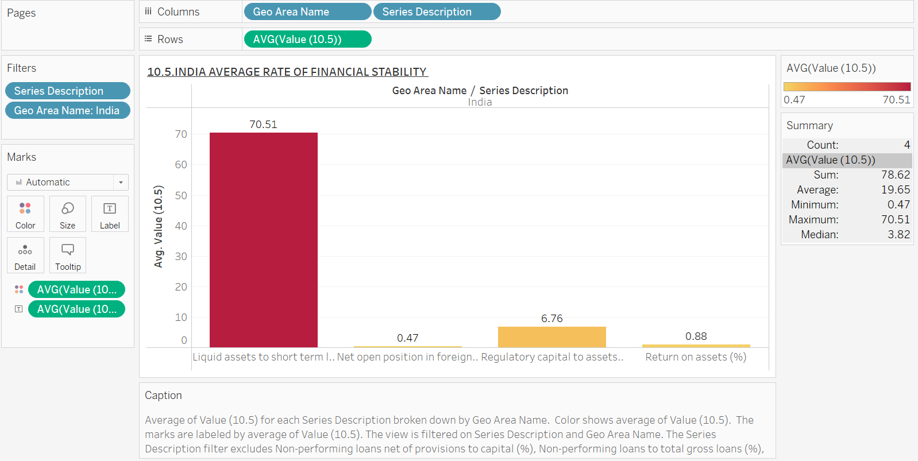

**ANALYSIS –** India’s high liquidity ratio indicates strong short-term financial security while the low foreign exchange exposure reduces its vulnerability to currency fluctuations. The moderate capital buffer suggests adequate financial safeguards but the low return on assets points to inefficiency in generating profits from the available resources, which could indicate challenges in profitability despite overall stability.

**INTERPRETATION –** The chart presents India’s financial stability based on four key metrics: liquid assets to short-term liabilities, net open position on foreign exchange, regulatory capital to assets and return on assets. The ratios show a very high liquidity position (70.51), minimal exposure to foreign exchange risk (0.47), a moderate regulatory capital buffer (6.76) and low profitability from assets (0.88).

**10.5. – 18. SAARC’S AVERAGE RATE OF FINANCIAL STABILITY PER YEAR (LEAVING AFGHANISTAN – DATA NOT PROVIDED)**

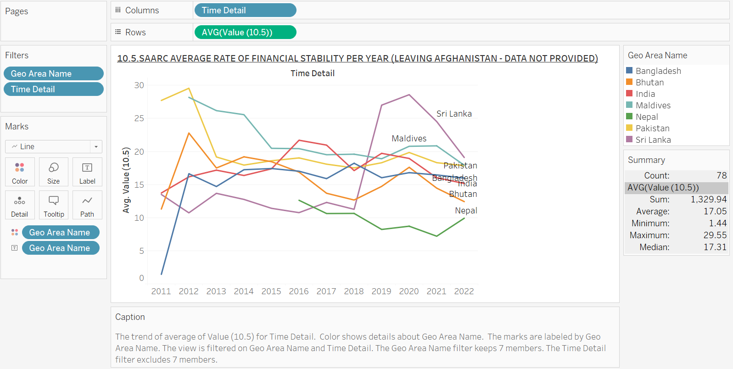

**ANALYSIS –** The volatility in countries like Maldives and Sri Lanka may reflect economic or political instability affecting their financial systems while India and Pakistan’s steadier rates suggest more consistent economic policies or financial systems. The consistently low rates for Bhutan and Nepal highlight their ongoing struggles with financial stability, possibly due to weaker economic fundamentals.

**INTERPRETATION –** This graph tracks financial stability in SAARC countries (excluding Afghanistan) from 2011 to 2022. Maldives and Sri Lanka show significant fluctuations, while Pakistan and India have relatively stable but lower stability rates. Bhutan and Nepal remain consistently low.

**10.5. – 19.INDIA’S AVERAGE RATE OF FINANCIAL STABILITY PER YEAR**

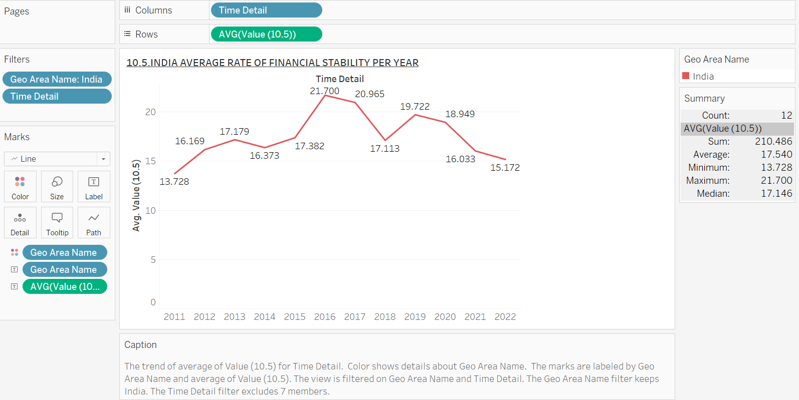

**ANALYSIS –** The peak in 2013 may reflect stronger economic conditions or reforms during that period, while the subsequent decline could indicate increasing economic challenges or reduced effectiveness of regulatory measures. The current stabilization suggests that while financial stability has weakened since 2013, increasingly rapidly in the year 2016 and reaching a relatively consistent level in recent years.

**INTERPRETATION –** This graph tracks India's financial stability rate annually from 2011 to 2022, showing an initial rise until 2013, followed by a gradual decline, stabilizing around 11-12 in recent years.

**10.5. GDP DASHBOARD**

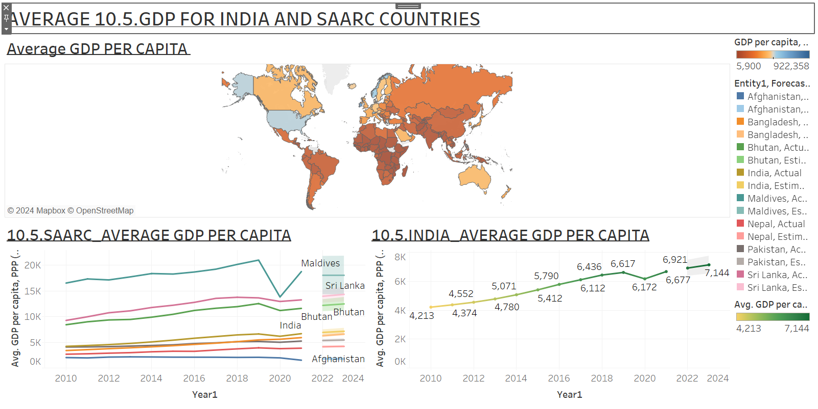

**ANALYSIS** – India’s GDP per capita, while growing, is relatively modest compared to other SAARC countries like the Maldives, which has significantly higher GDP per capita. This indicates that while India’s economy is large, the wealth per individual is lower compared to some neighbouring countries, pointing to income disparities and developmental differences within the region.

**INTERPRETATION** – This dashboard displays average GDP per capita for India and SAARC countries over time. India’s GDP per capita is shown alongside other SAARC countries, with a comparison to global GDP levels.

**10.5. WAGES DASHBOARD**

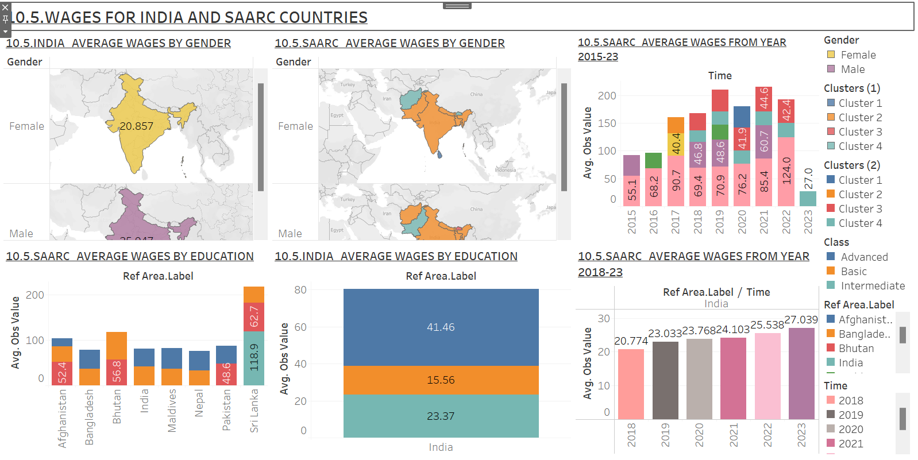

**ANALYSIS –** The wage disparity across gender is significant, indicating ongoing gender inequality in income levels within India and other SAARC countries. The fact that higher education levels result in significantly higher wages emphasizes the importance of education in improving economic outcomes. Countries like India show that investment in education could lead to better wage outcomes but gender-based income inequality remains a major challenge.

**INTERPRETATION -** The dashboard compares average wages by gender and education level for India and SAARC countries. The maps and bar charts show a clear wage gap between genders, with males earning significantly more than females. Additionally, wages based on education show a sharp contrast, with those having higher education qualifications earning much more than less-educated individuals.

**10.5. UNEMPLOYMENT DASHBOARD**

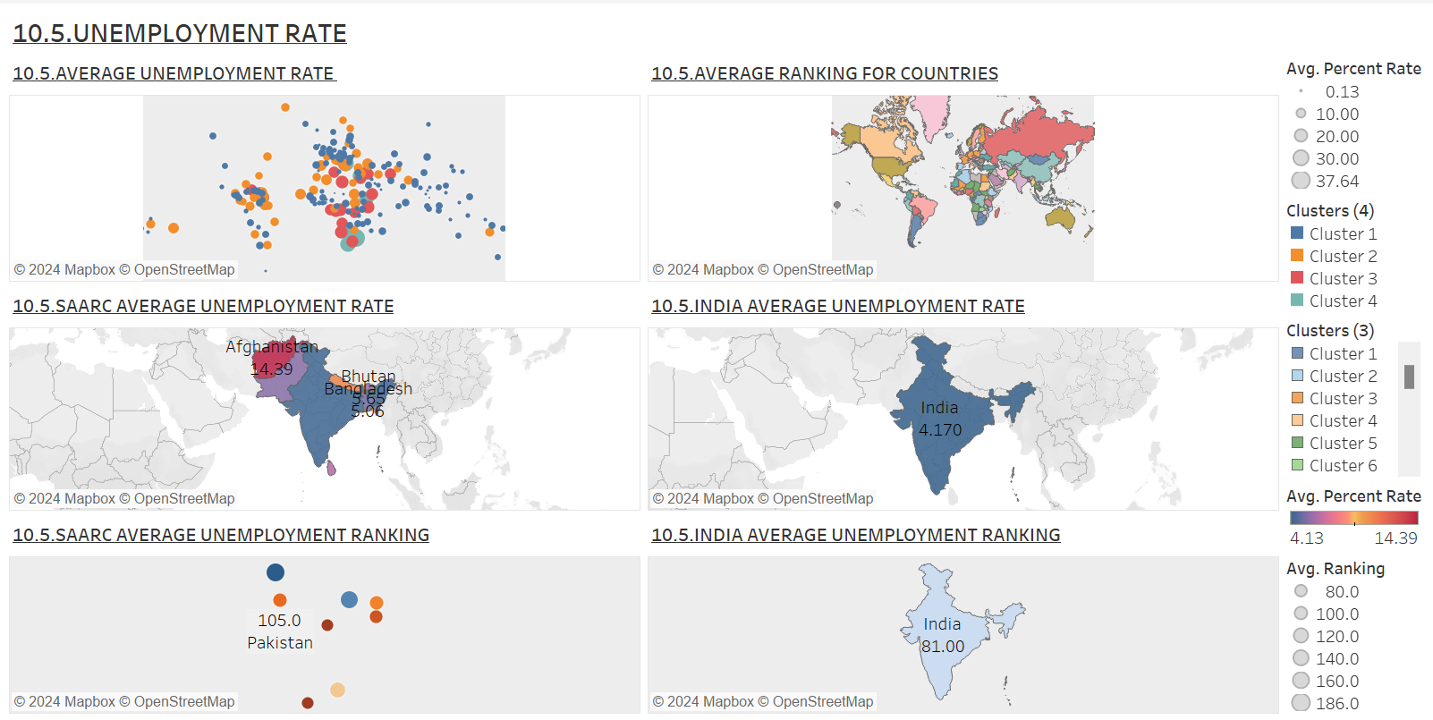

**ANALYSIS –** The unemployment map indicates regional clusters where unemployment rates are high, particularly in Afghanistan and some areas in Sri Lanka. This suggests economic challenges and possible inefficiencies in labour markets. India's unemployment ranking is lower compared to Pakistan, but it still shows a considerable percentage of the population struggling to find employment, reflecting issues such as skill mismatches, economic growth constraints or regional disparities in job availability.

**INTERPRETATION -** This section displays the unemployment rate in SAARC countries, alongside global comparisons. Maps show the distribution of unemployment rates, with India being highlighted. The unemployment rate ranking indicates that Afghanistan has a higher unemployment rate compared to other SAARC countries, while India has a moderately lower unemployment rate.

**10.5. FINANCIAL STABILITY DASHBOARD**

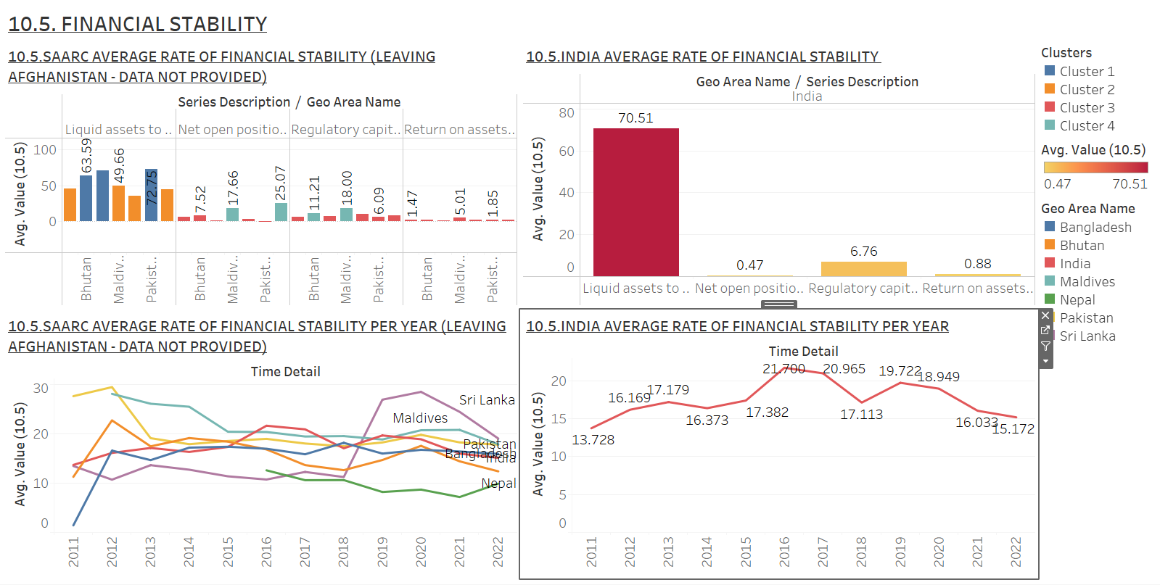

**ANALYSIS –** India's high liquidity ratio reflects solid short-term financial health, ensuring it can cover liabilities. However, the low return on assets signals inefficiencies in profitability, meaning the financial system is stable but not generating high returns. Other SAARC countries, such as the Maldives, show greater volatility, which could indicate greater exposure to financial risks or less effective economic policies. Stability in the financial system is essential, but India may need to improve how effectively its financial assets are being used to generate returns.

**INTERPRETATION** - This dashboard displays financial stability trends across SAARC countries, highlighting India's performance. The indicators show the rate of financial stability by country and the annual performance of India. India's stability metrics, such as liquidity and regulatory capital, show stability but return on assets remains low.

**10.5. FINANCIAL SOUND INDICATORS STORYBOARD**

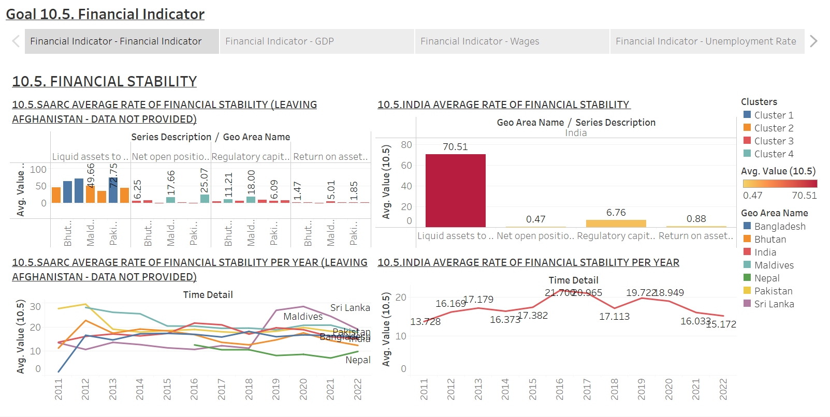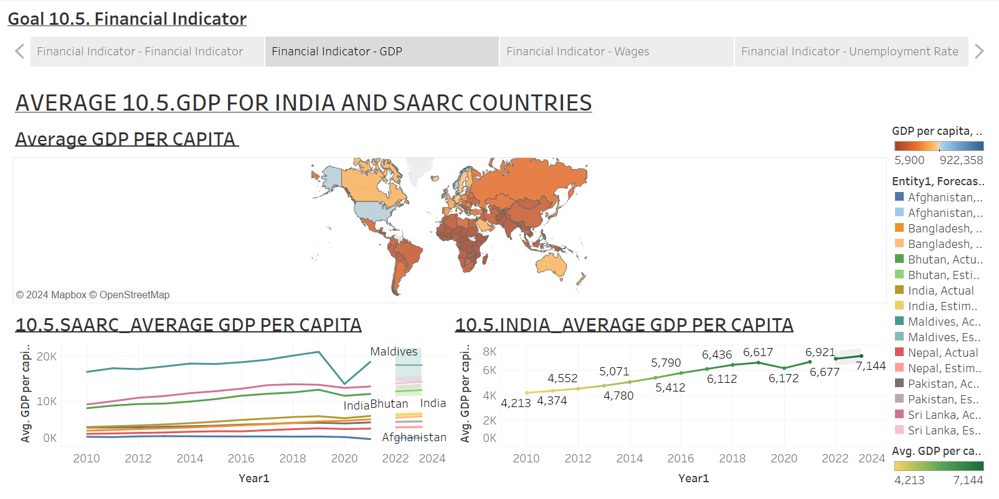 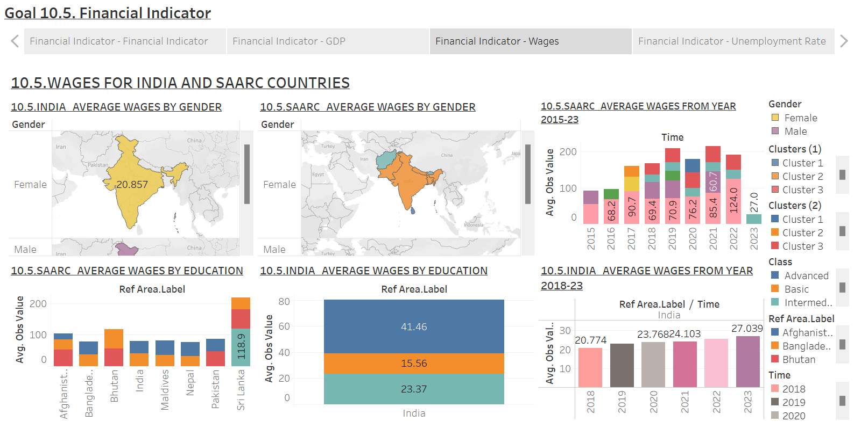 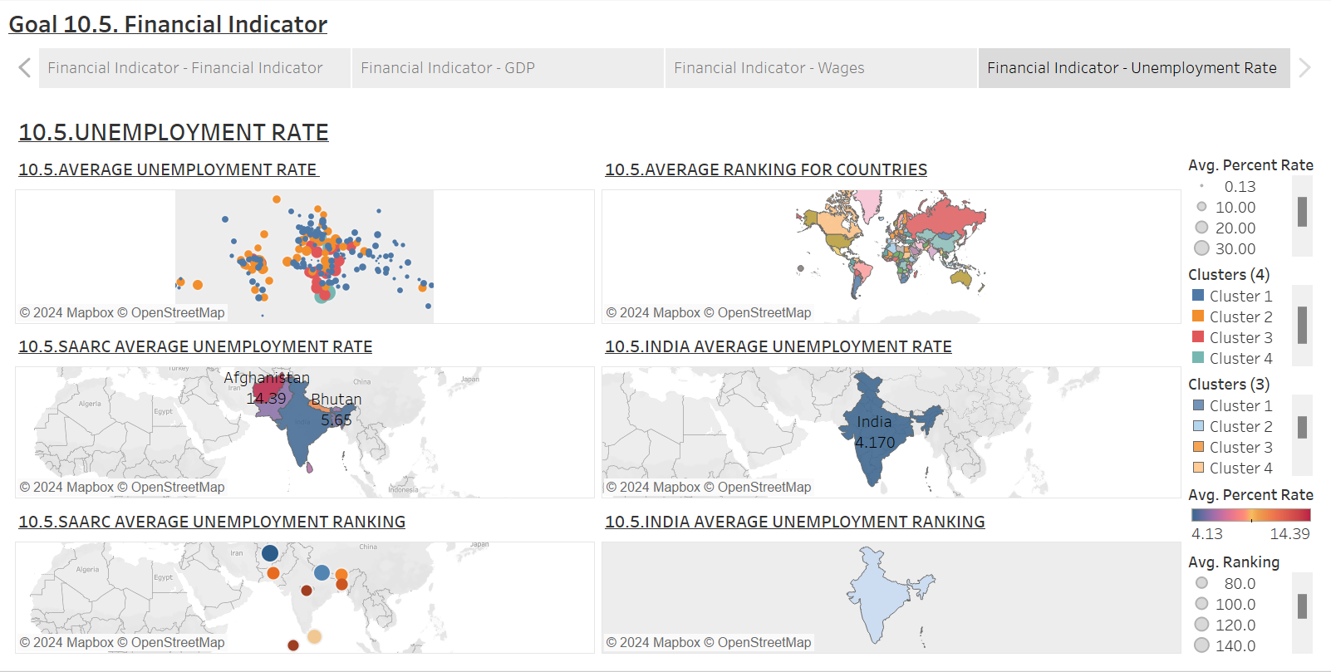

**ANALYSIS –** Despite India's excellent liquidity position, which promotes short-term financial health, the country's high unemployment rates and low return on assets seem to be obstacles to long-term economic resilience, according to the overall examination of these variables. The necessity for focused policy initiatives to increase labour participation and achieve income equality is highlighted by the persistence of the gender wage gap and the dependence of better wages on educational attainment. These problems must be resolved if financial stability is to be strengthened throughout the region. In India and other SAARC nations, economic inequality and inefficiency can impede sustainable progress and cause instability. Therefore, bolstering financial stability and advancing general economic success require creating an inclusive and effective economic environment.

**INTERPRETATION -** Together, the storyboard paints a complicated picture of India's and SAARC nations' financial health, emphasizing notable salary gaps, high unemployment rates and differing degrees of financial stability. The disparity in pay between genders reveals structural injustices and the need for education to advance economically highlights how important it is. In addition, the financial stability indicators show that although India has high liquidity, it has low returns on assets, which is a result of inefficient use of financial resources.

**10.6. – 1. RUSSIA’S AVERAGE HDI VALUE**

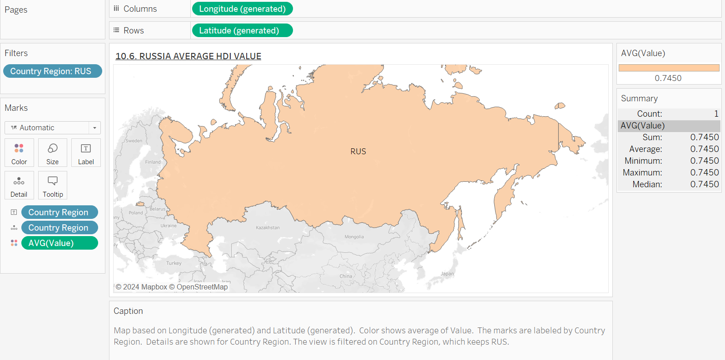

**ANALYSIS** – The graph shows the average Human Development Index (HDI) value for the country of Russia. An average HDI of 0.7450 is indicated by a consistent colour gradient. This number, which takes into account variables like wealth, life expectancy and education points to a comparatively high degree of human development. The uniformity of colour on the map suggests that there aren't any significant geographic variations in Russia's HDI, which could be a result of social initiatives and efficient government that support fair growth all around the nation.

**INTERPRETATION –** The majority of Russians appear to enjoy a respectable level of living, access to healthcare and education and a high and consistent HDI score. This may be a sign of effective national initiatives to advance human development. Though the average is high, it is important to remember that it does not take into consideration any potential regional problems that might occur, which could still have an impact on some resident’s overall quality of life.

**10.6. –2. AVERAGE HDI VALUE (NORTHERN COUNTRIES)**

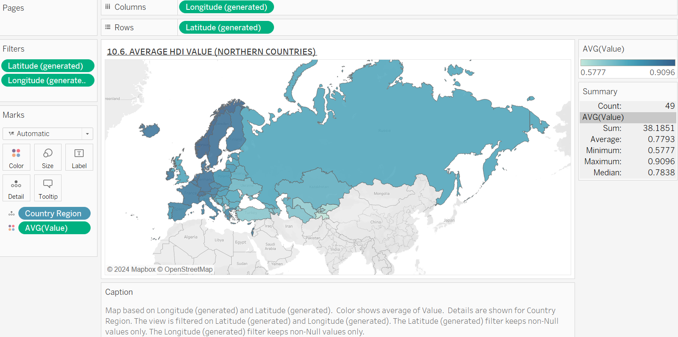

**ANALYSIS –** The second graph shows a color gradient-represented map of Northern nations with variable average HDI values. With an average HDI value of 0.7793, it is considered to be substantially higher than Russia's. The map shows significant differences in human development between various nations; certain areas have lower HDI scores, indicating problems with socioeconomic status, access to healthcare and educational possibilities.

**INTERPRETATION –** The average HDI score of Northern countries is greater than that of Russia, indicating that these countries may encounter lower difficulties in accomplishing the goals of human development. Numerous reasons, including as social inequality, restricted access to high-quality healthcare and education and economic instability could be to blame for this. Targeted interventions are required to improve human development outcomes in these locations due to the discrepancies illustrated in the map.

**10.6. – 3. HDI VALUE OF 3 MAJOR COUNTRIES PER YEAR**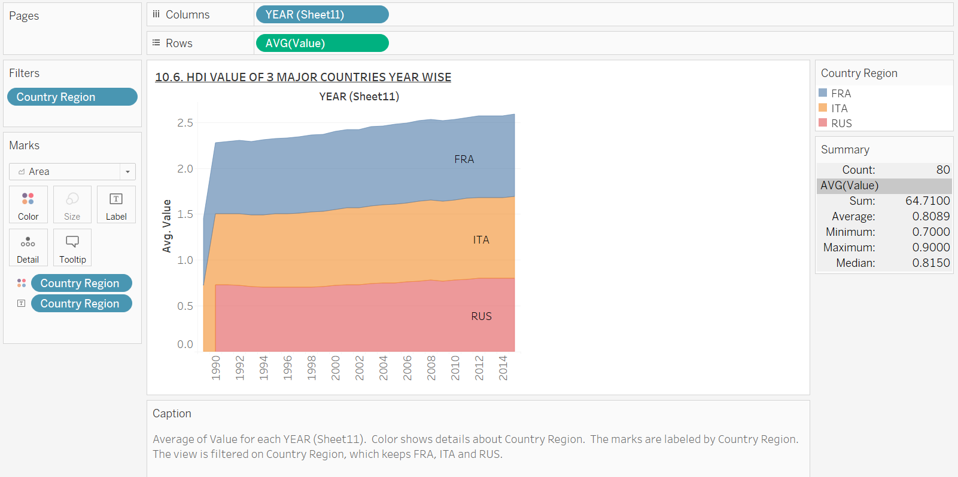

**ANALYSIS –** The graph is a line graph that shows the Russia, France and Italy HDI values from 1990 to 2014. According to the data, France continuously maintains the highest HDI scores, with Italy and Russia following suit. The human development index (HDI) of all three nations has gradually increased over time, pointing significant advancements in these metrics. The ongoing disparity between France and the other two nations however, raises the possibility that France had better socioeconomic circumstances or had more successful policies.

**INTERPRETATION –** While all three of the countries are making progress in terms of human development, France's lead reflects a more robust approach to social and economic policy, according to the patterns seen in the HDI values. Improvements in income levels, healthcare and education are reflected in the rising HDI values. The difference between these nations also emphasizes the necessity for Italy and Russia to study and implement effective French tactics in order to further improve their results for human development.

**10.6. – 4. SAARC’S AVERAGE PROPORTION RATE FOR MEMBERS AS WELL AS THEIR VOTING RIGHTS FOR SPECIFIC INTERNATIONAL INSTITUTIONS**

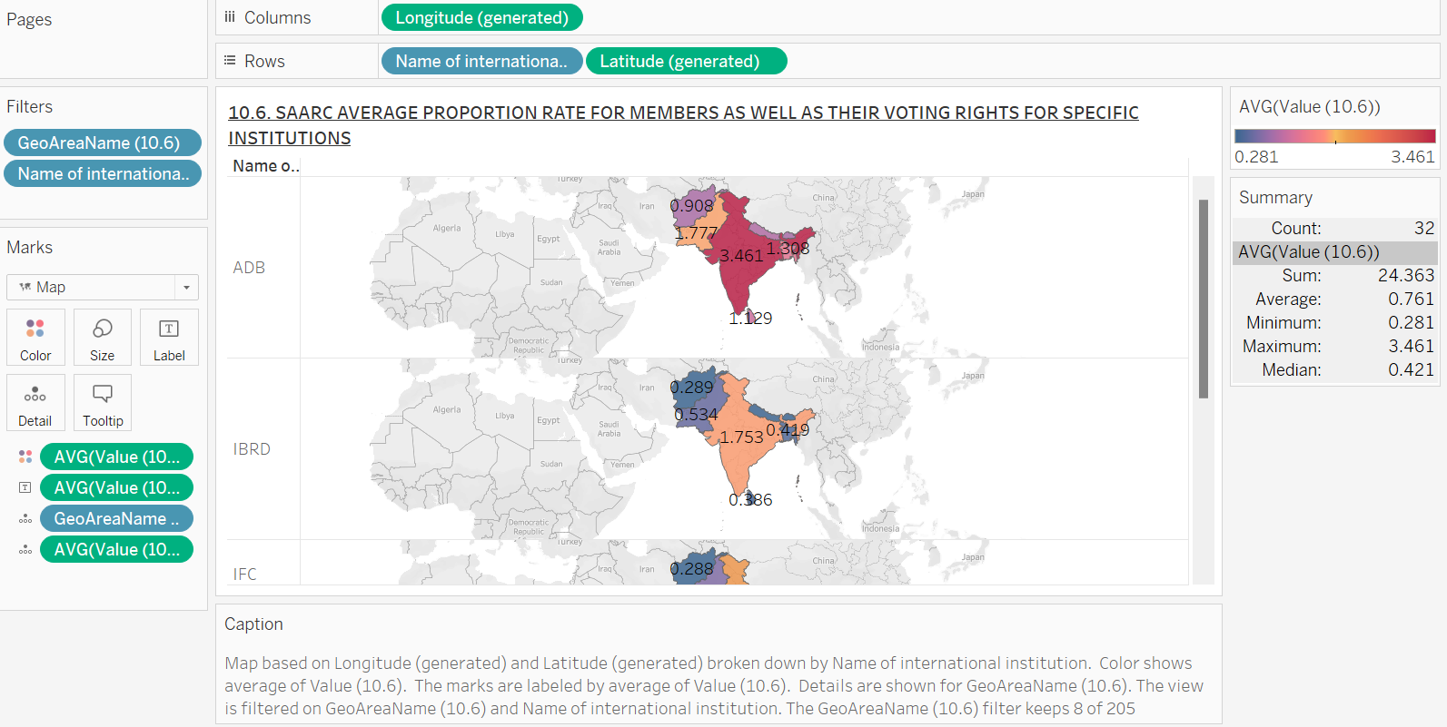

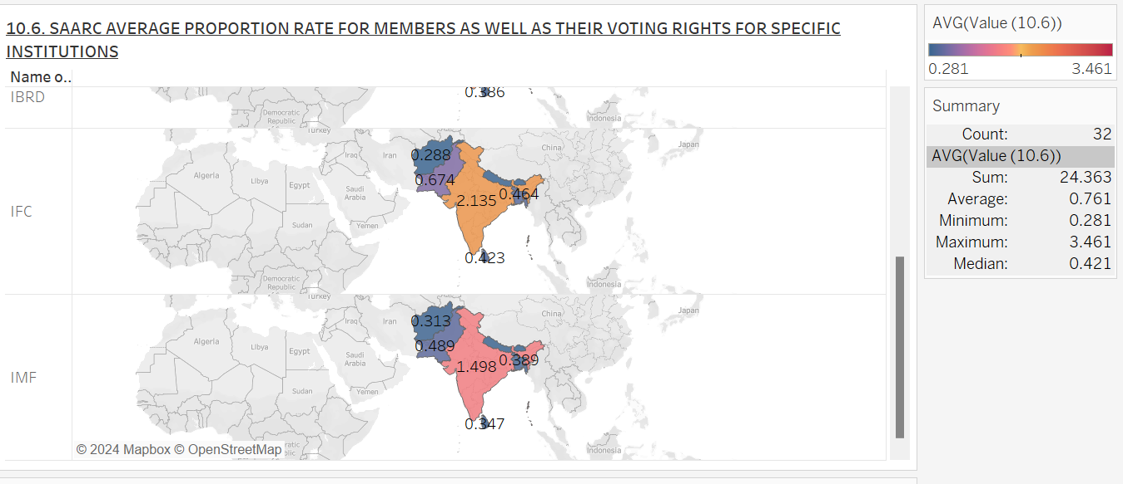

**ANALYSIS –** The data on voting rights in different international institutions and the average proportion rate for members of the South Asian Association for Regional Cooperation (SAARC) are displayed in the graphs. The average proportion rate and the voting rights of these members among SAARC members is depicted in the graph using a color gradient. This implementation makes it possible to compare democratic representation and engagement across the SAARC region visually, highlighting areas that might need policy attention and improvement.

**INTERPRETATION –** The graph suggests differences in representation by showing different average proportion rates among SAARC member countries. Some nations may have lower rates, suggesting potential obstacles to participation, while others, like Bangladesh and India may have greater rates, indicating stronger involvement in decision-making processes. The examination of these graphs highlights the necessity of focused reforms to improve democratic engagement and guarantee fair representation in each of the member nations, tackling structural problems that could impede efficient government.

**10.6. – 5. INDIA’S AVERAGE PROPORTION RATE FOR MEMBERS AS WELL AS THEIR VOTING RIGHTS FOR SPECIFIC INTERNATIONAL INSTITUTIONS**

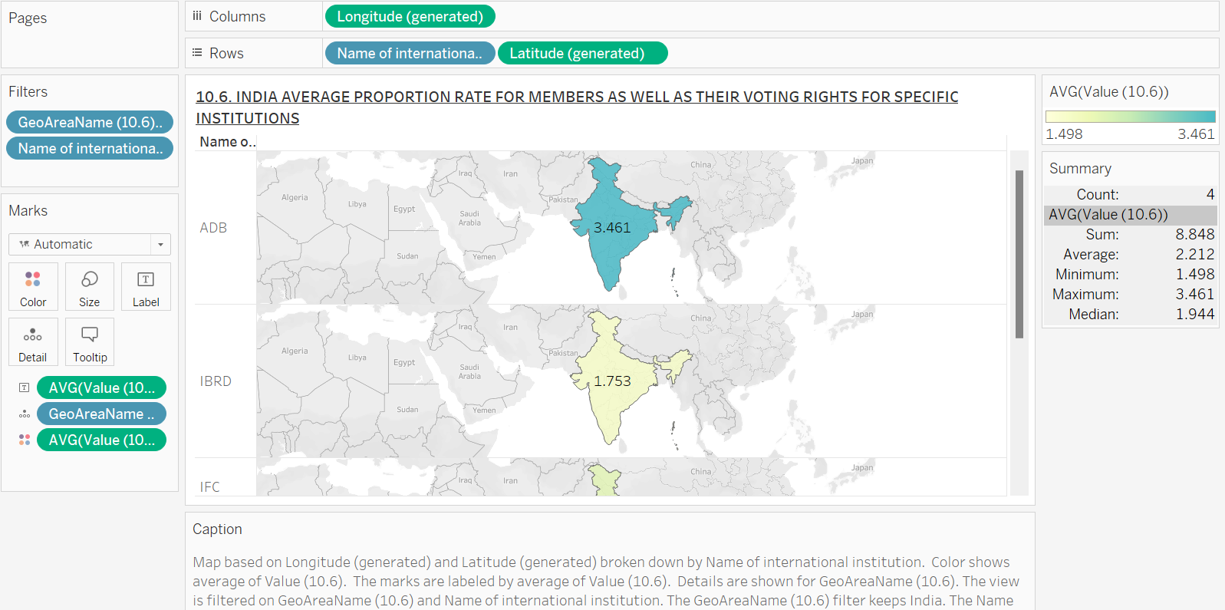

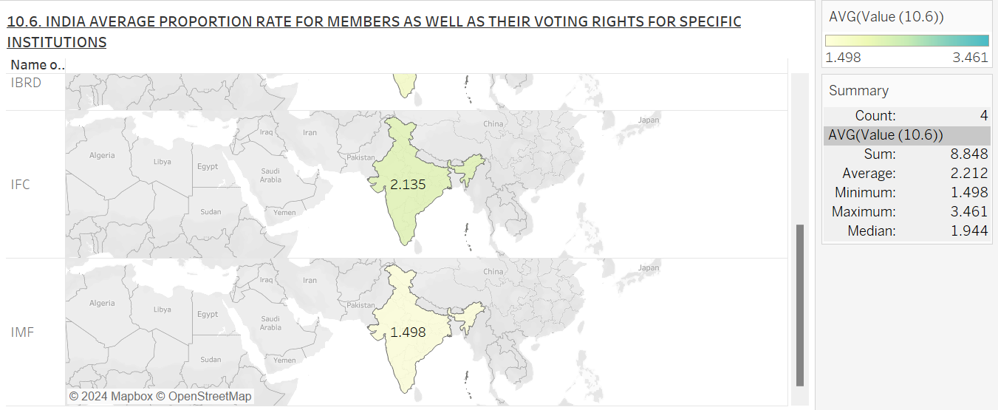

**ANALYSIS** – The graph suggests that India is significantly represented in decision-making processes due to its comparatively high average proportion rate. On the other hand, disparities in voting rights among various institutions can indicate uneven approaches to managing representation. Based on a comparison of India's voting rights with those of other SAARC countries, it also shows that although India does well in terms of representation, there are still differences among the member states. The present analysis underscores the significance of conducting ongoing assessments of voting rights and representation in India and underscores the possibility of India functioning as a prototype for augmenting democratic procedures in adjacent nations. The results indicate that in order to promote a more inclusive political climate and strengthen voting rights throughout the SAARC region, cooperative measures are required.

**INTERPRETATION –** The average proportion rate of members in India and their ability to vote in different institutions are the main subjects of the graphs, which also provide a comparison of these rights with those of other SAARC members. An in-depth analysis of India's democratic engagement in comparison to its regional rivals is made possible by this implementation.

**10.6. – 6. SAARC’S COMPARING AVERAGE PROPORTION RATE FOR MEMBERS AS WELL AS THEIR VOTING RIGHTS FOR SPECIFIC INTERNATIONAL INSTITUTIONS**

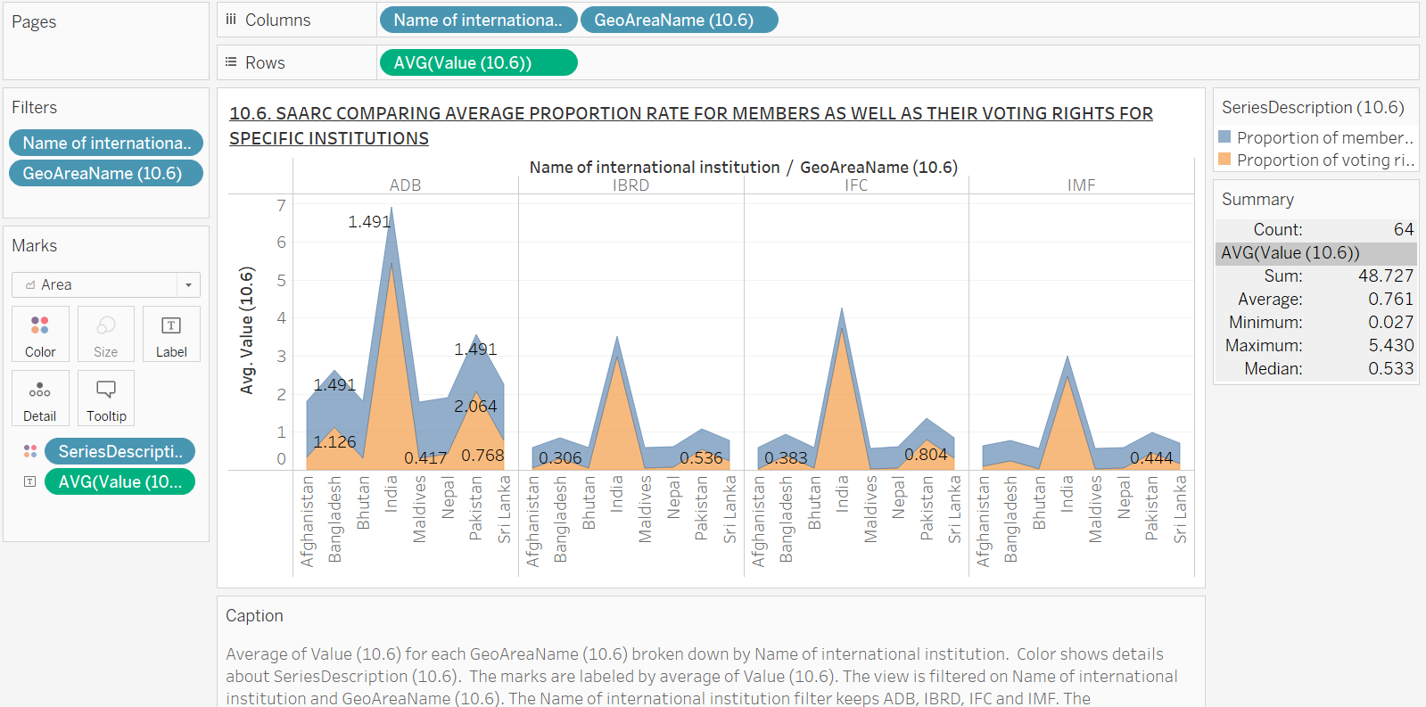

**ANALYSIS –** The graph shows that the various institution’s average proportion rates vary, with some exhibiting higher representation than others. In contrast to the IMF, the ADB might, for instance have a higher average proportion rate, indicating that its member nations have greater sway over particular issues. The differences in representation are emphasized in this analysis, along with any possible ramifications for these institution’s decision-making procedures. It emphasizes how important it is for SAARC member nations to push for increased representation in global governance bodies in order to increase their involvement and influence.

**INTERPRETATION –** The average proportion rate for South Asian Association for Regional Cooperation (SAARC) members across several international organizations is shown in the graph. The average proportion rates for organizations like the Asian Development Bank (ADB), the World Bank (BRD), the International Finance Corporation (IFC) and the International Monetary Fund (IMF) are shown in this graph using a bar chart format. This implementation makes it possible to compare the representation of SAARC member nations in different organizations in a clear and visual manner.

**10.6. – 7. INDIA’S COMPARING AVERAGE PROPORTION RATE FOR MEMBERS AS WELL AS THEIR VOTING RIGHTS FOR SPECIFIC INTERNATIONAL INSTITUTIONS**

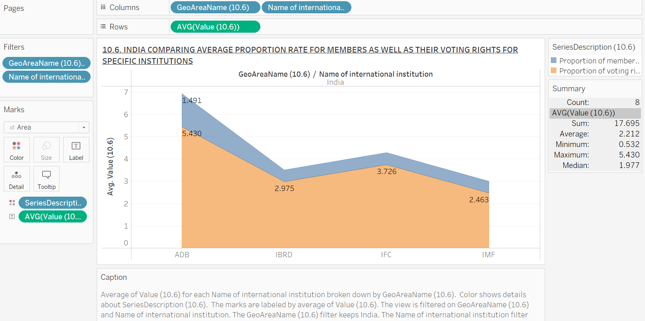

**ANALYSIS –** According to the graph, India has a comparatively high average proportion rate across a number of institutions, indicating a large presence and impact. Nonetheless, discrepancies in the rates among various institutions can indicate uneven representation of India. This analysis emphasizes how critical it is to comprehend the institutional policies and political dynamics that give rise to these differences. It emphasizes how important it is for India to participate actively in international fora in order to defend its rights and make sure that its representation reflects its rising political and economic prominence.

**INTERPRETATION -** The average proportion rate of India’s membership in various international institutions is the subject of the second graph. This graph gives a clear picture of India’s voting rights and influence by showing its presence in organizations like the ADB, BRD, IFC and IMF using a bar chart format.

**10.6. – 8. SAARC’S COMPARING AVERAGE PROPORTION RATE FOR MEMBERS AS WELL AS THEIR VOTING RIGHTS OVER THE TIME FOR SPECIFIC INTERNATIONAL INSTITUTIONS**

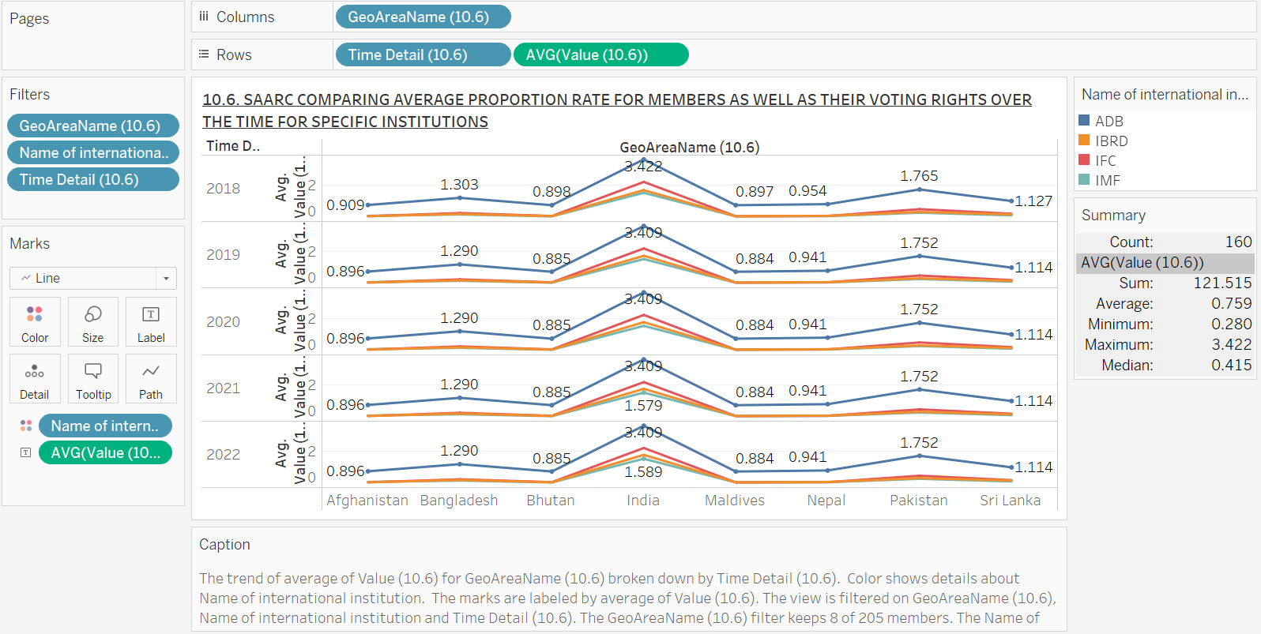

**ANALYSIS –** Voting rights trends are shown in the line chart, which shows variations over time. Voting rights may be increasing in certain countries while decreasing in others. According to this analysis, member country’s voting rights can be greatly impacted by the political situation and international relations. The disparities in voting rights serve as a reminder of the significance of ongoing observation and support for fair representation in international organizations. It underlines how crucial it is for SAARC nations to work together and amplify their voice in order to guarantee equitable representation and voting rights.

**INTERPRETATION -** The graph shows the SAARC member nation’s voting rights in several international organizations. Using a line chart, this graph shows the trends in voting rights over time, providing a dynamic view of how these country’s representation has changed in organizations such as the ADB, BRD, IFC and IMF.

**10.6. – 9. INDIA’S COMPARING AVERAGE PROPORTION RATE FOR MEMBERS AS WELL AS THEIR VOTING RIGHTS OVER THE TIME FOR SPECIFIC INTERNATIONAL INSTITUTIONS**

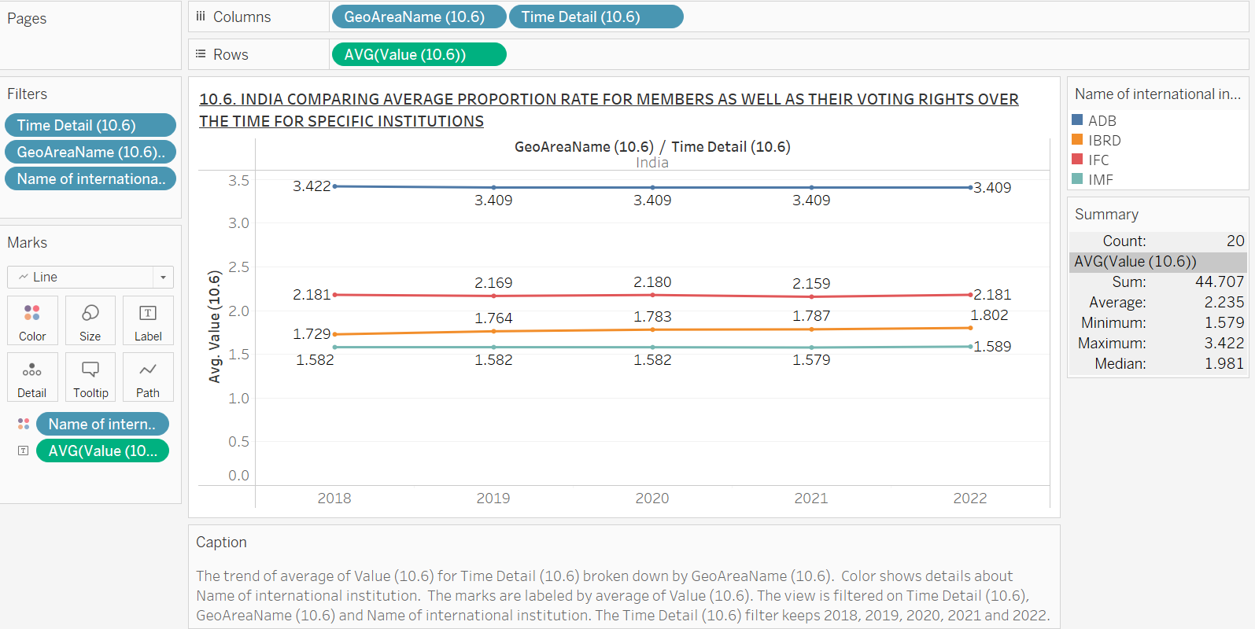

**ANALYSIS –** Based on a comparative research, voting rights in India have fluctuated throughout time, with certain institutions exhibiting an upward tendency and others possibly declining or stationary. The present research highlights the imperative for India to actively participate in global opportunities in order to champion its concerns and guarantee that its portrayal corresponds with its growing economic and political importance. While India has a relatively high degree of voting rights, the patterns seen in this graph indicate that continued efforts are required to rectify any inequities and increase its influence in discussions about global governance.

**INTERPRETATION –** India's vote rights in numerous international institutions over time are shown in detail in the graph. India's voting rights at various institutions, including the ADB, BRD, IFC and IMF are depicted in this graph using a line chart, providing a comprehensive view of the evolution of India's representation.

**10.6. HDI DASHBOARD**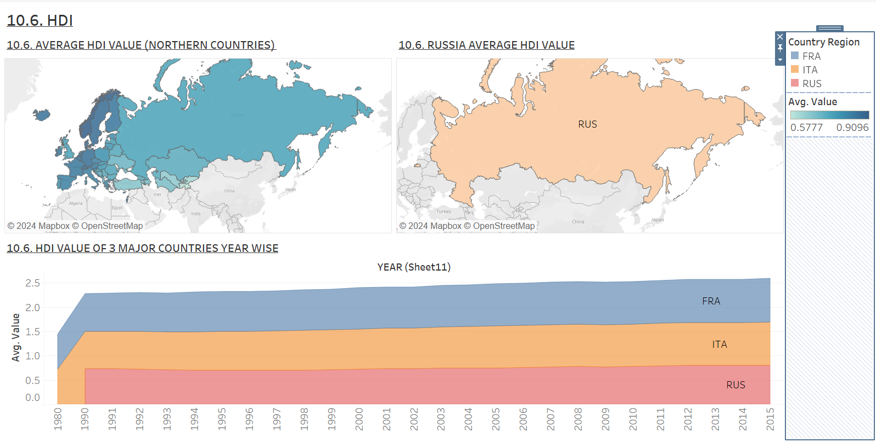

**ANALYSIS –** The HDI dashboard compares human development across Northern Europe, Russia, France, and Italy from 1980 to 2015. Northern countries average 0.7793, indicating high development through strong welfare systems. Russia, with an HDI of 0.745, shows improvement post-Soviet era but lags behind Western Europe. France leads with the highest HDI, reflecting stable growth and effective social policies, while Italy closely follows with consistent advancements in human development.

**INTERPRETATION –** This underscores the disparities in human development among the northern states, implying that whilst certain nations are advancing, others are falling behind. The differences in HDI ratings highlight the need for focused legislation and cross-regional collaboration to address the root causes influencing human development. Enhancing chances for economic growth, healthcare and education in nations with lower HDI scores can assist raise those nation’s scores and promote regional development as a whole.

**10.6. MEMBERSHIP PROPORTION DASHBOARD**

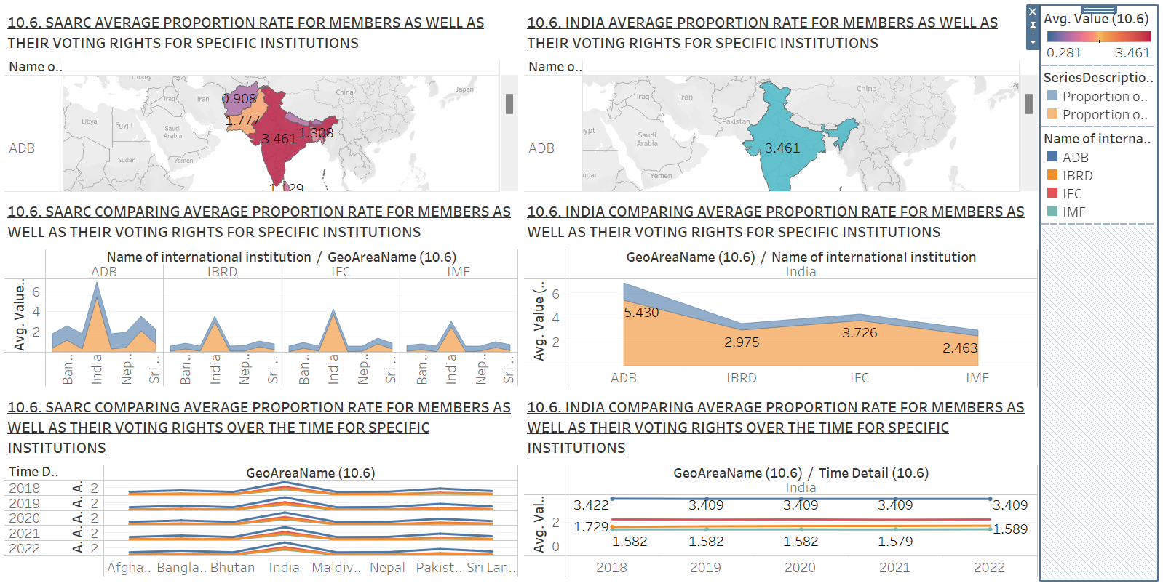

**ANALYSIS –** In a number of organizations India exhibits a comparatively high average proportion rate, indicating noteworthy representation. But there are differences throughout other organizations, suggesting that India's impact is not consistent.

**INTERPRETATION** – Despite efforts to increase the participation of developing nations in international institutions, the patterns indicate that notable gaps still exist. These differences may affect these nation's capacity to shape international laws and policies. In order to ensure that the views of developing nations are heard in international governance, the research emphasizes the significance of ongoing campaigning for fair voting rights and representation. Together, these nations have the power to increase their influence and advance reforms that advance equitable representation in international organizations.

**10.6. MEMBERSHIP PROPORTIONS STORYBOARD**

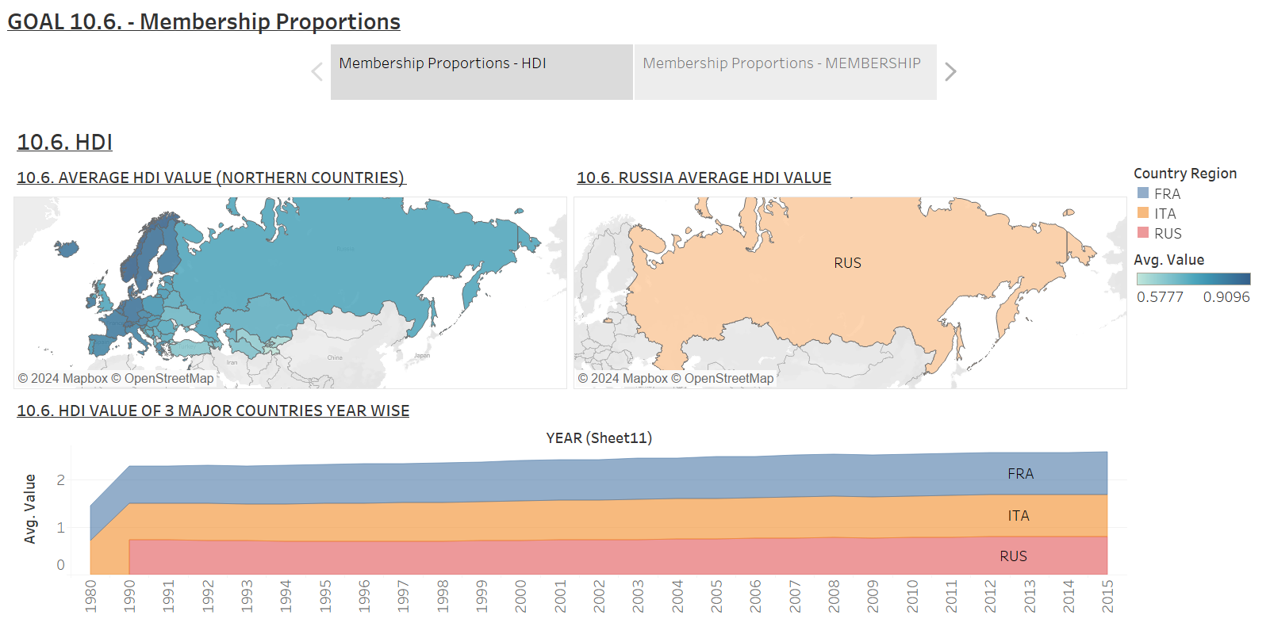 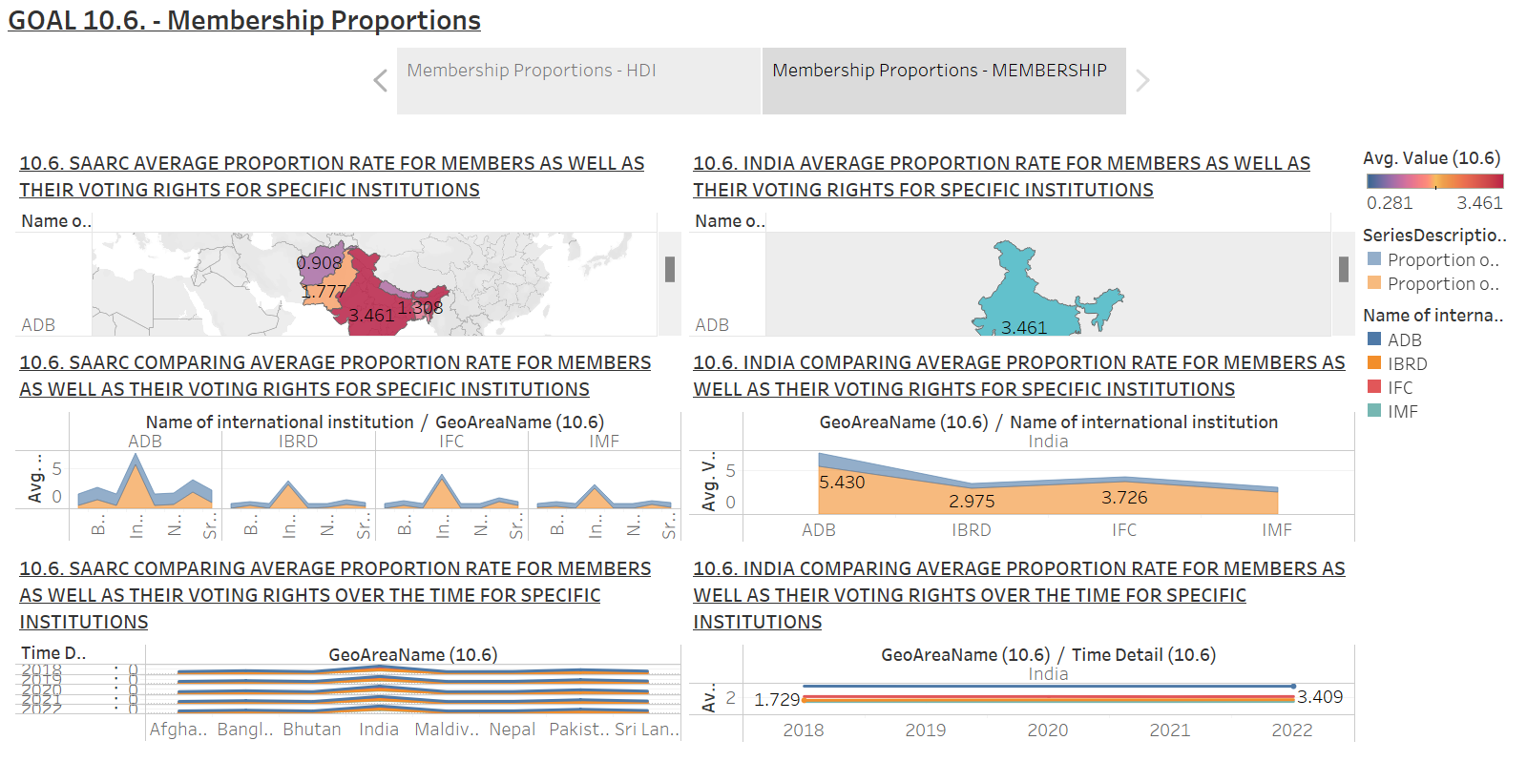

**ANALYSIS –** There are notable differences in human development throughout thenorthern countries, as seen in the graph of the country's Human Development Index (HDI). Higher HDI scores indicate greater performance in health, education and income in countries like Russia and Italy, whereas significant issues are faced by other nations. It also demonstrates changes in representation and voting power over time, focuses on the membership and voting rights of emerging nations in international organizations. This suggests that whereas several developing nations have achieved success in gaining increased representation, others still face challenges in having a limited impact on global governance.

**INTERPRETATION –** The differences in HDI scores show how urgently focused policies and regional collaboration are needed to address the root causes impacting human development in the countries with lower HDI scores. Gains in human development can help a nation participate more successfully in international fora. In addition, the changes in voting rights and membership emphasize how crucial it is that emerging nations have fair participation in international governance frameworks. Taken together, these observations imply that in order for poor nations to become more visible and have a greater impact on international policy, they must improve their membership and vote rights in international organizations. Developing nations may contribute to a more equitable international system that fosters sustainable development and ensures that their interests are fairly reflected in international decision-making processes by addressing both human development and representation. In order to achieve equity and long-term progress in both regional and global contexts an integrated approach is needed.

**CONCLUSION**

This analysis emphasizes the crucial connection between developing country representation in international organizations and financial soundness indicators including GDP per capita, wages and unemployment rates. Economic inequality is clearly still present within and between nations, with differences depending on factors such as gender, level of education and general financial stability. These disparities further worsen by poor nations' underrepresentation in international decision-making bodies and their restricted ability to vote.  
  
It is essential to promote policies that improves financial stability, promote wage parity and guarantee developing country’s equitable representation in international institutions in order to attain sustainable development and minimize inequality. The international community can move toward a future that is more inclusive and equitable by tackling these important issues.  
  
**BIBLIOGRAPHY AND REFERENCES**

* <https://en.wikipedia.org/wiki/List_of_intergovernmental_organizations>
* <https://gateway.euro.who.int/en/indicators/hfa_42-0500-undp-human-development-index-hdi/#id=18849>
* <https://ourworldindata.org/human-development-index>
* <https://www.sciencedirect.com/science/article/abs/pii/S0305750X9700034X>
* <https://sdgdata.gov.uk/10-6-1/>
* <https://databank.worldbank.org/source/worldwide-governance-indicators>

**GitHub Link**

* <https://github.com/KhushiSanwal/2341447-TABLEAU-GOAL-10.5.-AND-10.6./blob/c889c4fe90046d77ca868f634c28c1fc5a556aec/2341447%20CIA%203.twb>